DEVELOPMENT OF AN ONLINE VISITOR
GATEPASS MANAGEMENT SYSTEM
(A CASE STUDY OF OGITECH SECURITY GATE, IGBESA)

A PROJECT REPORT SUBMITTED TO
THE DEPARTMENT OF COMPUTER SCIENCE
SCHOOL OF PURE AND APPLIED SCIENCE
OGUN STATE INSTUTE OF TECHNOLOGY, IGBESA

SUBMITTED BY

IN PARTIAL FULFILLMENT OF A COURSE REQUIREMENT
FOR THE AWARD OF HIGHER NATIONAL DIPLOMA
(HND) IN COMPUTER SCIENCE

AUGUST, 2018.

CHAPTER ONE
1.0 Introduction
Gate Pass Management System is a software application. It manages the entry and exit of the vehicle of employees and visitors. Gate Pass Management System is an efficient system to keep track of each vehicle entry and exit.
Gate Pass Management System (GPMS) Allow you to manage all Incoming and Outgoing items from your office or company. Gate Pass Management System is available for use and it is easy to use and manage. This system is defined as a gate pass security system and its main aim to secure company from outside visitors, contractors and the departments, company vehicle security, material, visitor scrap information, contractor.
Gate Pass Management System help the organization as well as a visitor to manage the Gate Passes. Frequently Visitors have data entry in top level to make them easily entry and exit.
Visitor Management system provides a way to effectively control, record & track your organization's visitor traffic. It helps to prevent the entry of any unauthorized or unwanted person in the premises. The flexible architecture of Visitor Tracker System allows various people in the organization to directly access the data they need. Integrated with various hardware’s like web-cam, fingerprint scanner, bar-code scanner & printers. Email/SMS/popup alerts for visitor notification. Available in client-server & Enterprise versions.
Visitor Management System has 3 modules with user specific roles.
- Administrator Module: This module is generally installed on the Security Administrator PC. It consists of the menu where administrator can define, Companies, Host details, User Right Management, Set Gate pass formats, Generate Reports
- Host Employee Module: The host employee can check the visitor details on the web pages. Pop up client is also available which notifies the host about the visitor.
- Host can send the response to the security gate staff.
- Security Gate Module: The Security Gate module is installed at the entrance of the premises. It facilitates the staff at security gate to register the visitor’s details with photograph and also send the notification to the host employee inside the premises. The system will print visitor pass with name of visitor and other details as per designed gate pass format. Security can handover generate gate pass in required format to visitor.
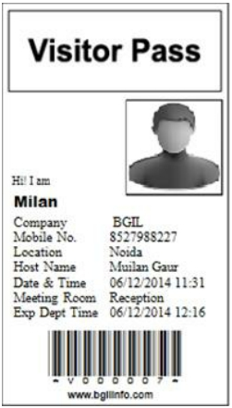

Figure 1: Sample of Visitor Card
1.1 Background of the study
We have seen various industries/institutes where there is a compulsion of taking a gate pass to
enter the premises as well as while leaving the premises before time. The gate pass is generally either a written chit of paper or a receipt sheet. This sheet remains of no use once out of the premises and there is wastage of paper. Our system proposes to give the “Paper Saving Idea” for the same. It consists of a design where the visitor can enter the required details viz. visitor id, name, contact, reason to enter/leave, and where he/she will enter this on a touch screen enabled kiosk system where this information will be further redirected to the higher authority in the organization. The higher authority would contain the details of the visitor from database. If this is true then details of visitor would be saved into database & once it is done the permission is granted, then the respected visitor will get a confirmation that he/she is allowed to enter/leave the premises before time.
1.2 Problem Statement:
Managing visitors at student’s accommodations is one of the major problems faced by the OGITECH administration that deals with student’s visitors’ accommodation. Present system of working by the security management is that the security staff at the guard houses of these OGITECH students accommodation, visitors come and provide identity proof and then they provide unit and block number which they wish to visit. The security guard at the guard house will call the student of the unit number given by the visitor then the student resident will acknowledge that the visitor at the guard house is his visitor, once the resident has been acknowledged the security guard shall allow the visitor to enter the accommodation. Visitor management at the OGITECH student right now is manual which consumes a lot of time of the visitors who need to wait for the security guard to call the OGITECH student to acknowledge he has a visitor. All this is time consuming more so when there is a rush of visitors at the guard house. For the student resident it is more discomfort when there is a get together of friends since for each visitor he has to attend phone calls from the guard house which leads to consume much of his party time attending calls.

1.3 Goal of Gate Pass Management System
This new online system is used to define the allowed personnel authorized to allow access by car to guests. Which means for every entry there is someone responsible for.
The end user will have secured web interface i.e. GATE PASS MANAGEMENT SYSTEM to enter the guest details with inviter credentials which will be processed for validity and up on success will be accessible online to Security personnel occupying the gate post. Now system would have information who is visiting, for what purpose for, who has invited him.
The invitation will be kept in the database and will be available to the Security staffs and to the invitees. Admin can view any record at any point in time.
Full web based administration and report engine were implemented based on SQL queries. The database has all records and safety measure of records.
1.4 Aim and Objectives of Gate Pass Management System
The aim of this project is to analyze, design and implement a web based system visitor gate pass Management system for Ogun state institute of technology, security unit.
The objective are:
- To provide student’s safety and monitoring.
- To allow the students to upload their personal details.
- To provide easy access of searching and navigation.
- To generate overall reports.
- To send notifications for the users
- To generate SMS alert and instant mailing and messaging.
1.5 Limitation of the study

The main limitation of the previous system of Gate Pass Management System:
- The existing system only provides text-based interface, which is not as user-friendly as Graphical user Interface.
- Since the system is implemented in Manual, so the response is very slow.
- The transactions are executed in off-line mode, hence on-line data capture and modification
- Off-line reports cannot be generated due to batch mode execution.
Hence, there is a need of reformation of the system with more advantages and flexibility. The Gate Pass Management System eliminates most of the limitations of the existing software. It has the following objectives:

Enhancement: The main objective of Gate Pass Management System is to enhance and upgrade the existing system by increasing its efficiency and effectiveness. The software improves the working methods by replacing the existing manual system with the computer-based system.

Automation: The Gate Pass Management System automates each and every activity of the manual system and increases its throughput. Thus the response time of the system is very less and it works very fast.

Accuracy: The Gate Pass Management System provides the uses a quick response with very accurate information regarding the users etc. Any details or system in an accurate manner, as and when required.

User-Friendly: The software Gate Pass Management System has a very user-friendly interface. Thus the users will feel very easy to work on it. The software provides accuracy along with a pleasant interface. Make the present manual system more interactive, speedy and user friendly.

Availability: The transaction reports of the system can be retried as and when required. Thus, there is no delay in the availability of any information, whatever needed, can be captured very quickly and easily.

Maintance Cost: Reduce the cost of maintenance.
1.6 SCOPE OF THE PROJECT
This is an online gate pass management system. With this, management of visitors and activities at the gate of an organization or institution is absolutely easy. The system has a wide array of interesting features like:
- You can register gate guards as the admin who will be managing different gates.
- Management of visitors, individual visitors and group visitors.
- You can keep track of the entry and exit times of all visitors including staff.
- You can register staff members also into the system.
- Capture vehicle details.
- Capture luggage details.
- Approve or disapprove visitors from getting into the gate and provide reasons why.
CHAPTER TWO
LITERATURE REVIEW
2.1 What is the Gate Pass System?
Gate Pass System is a desktop application software for visitor management to the organization’s premises. It helps organizations manage the daily visitors to their premises by providing a simple interface and easy to use drop down menu driven software that can be easily used by anyone.

2.2 Why Choose Gate Pass System?
Any organization that has visitors in its premises be it in the industrial or manufacturing area or a corporate office, must keep proper track of the visitors and ensure the visitors carry proper id tags and visitor passes. A manual entry process is cumbersome and tends to be prone to errors. Gate Pass System helps standardize the process and dashboard functionality even provides the count of visitors in at any point of time and the total visitors for each day. The Gate pass system is a must have for all small, medium and large organizations that wish to keep record of visitors for compliance and reporting as well. There are varieties similar systems available in the market when you search visitor management system in any of search engine available. Those systems come with various features to offer to their customer with different price range.
2.3 Domain Research
The Visitor Management system by applying the model of UTAUT was discussed by Norizan Anwar, Mohamad Noorman Masrek, Yanty Rahayu Rambli in year 2012. They proposed the system by adopting technology model (UTAUT) to determine the user acceptance of visitor application system. The main motto of this system was “Handling your visitor at your fingertips”.
Another system for Visitor Pass was discussed in the paper by Prof. Abhay Gaidhani, Suraj Sahijwani, Parag Jain, Shantanu Jadhav, Ankush Jain in year 2015. This paper aims to develop a system for Gate pass using Raspberry Pi. The main aim was
to save paper with the help of Internet Connectivity to send SMS and Email for verification of user. Digital Visitor Information Management System (VIMS) Application and Design. This application enables capturing new visiting record by auto-clock in/out, and assignment of visitor pass. Visitor information are recorded in a centralized database server, which provides data management and manipulation through searching and report generating.
E-VIMS able to record visitor information during visitor registration by using visitor’s Malaysia Government Multipurpose Card (MyKad). On the other hand, the decision to develop a visitor system may depend on the needs of an organization so in this review
paper we have discussed a Visitor Gate Pass Management System to enhance level of security and manage visitor in any organization. Organizations need to take care of security measures concerning visitors management and tracking. Corporate offices will get too many number of visitors every day for many reasons such as interviews, parcel deliveries.
By introducing a visitor management system that allows organizations to track visitors on daily basis by introducing procedures such as ID registration, visitor approvals , process management , pass or badge and record keeping.
2.4 History
since September 11, 2001, many companies and government agencies enhanced building security by including access control and documenting visitors. The most defining event illustrating the need to enhance school security worldwide occurred in Beslan, Russia on September 1, 2004. A group of mostly Chechen terrorists took over a school and held more than 1,100 hostages for three days until Russian security forces stormed the building. A severe firefight ensued and ultimately over 350 people died, including 184 children. There are varieties similar systems available in the market when you search visitor management system in any of search engine available. Those systems come with various features to offer to their customer with different price range.
The Visitor Management system by applying the model of UTAUT was discussed by Norizan Anwar, Mohamad Noorman Masrek, Yanty Rahayu Rambli in year 2012. They proposed the system by adopting technology model (UTAUT) to determine the user acceptance of visitor application system. The main motto of this system was “Handling your visitor at your fingertips”.
Another system for Visitor Pass was discussed in the paper by Prof. Abhay Gaidhani, Suraj Sahijwani, Parag Jain, Shantanu Jadhav, Ankush Jain in year 2015. This paper aims to develop a system for Gate pass using Raspberry Pi. The main aim was to save paper with the help of Internet Connectivity to send SMS and Email for verification of user.
Digital Visitor Information Management System (VIMS) Application and Design. This application enables capturing new visiting record by auto-clock in/out, and assignment of visitor pass. Visitor information are recorded in a centralized database server, which provides data management and manipulation through searching and report generating. E-VIMS able to record visitor information during visitor registration by using visitor’s Malaysia Government Multipurpose Card (MyKad).
On the other hand, the decision to develop a visitor system may depend on the needs of an organization so in this review paper we have discussed a Visitor Gate Pass Management System to enhance level of security and manage visitor in any organization.
Shortly afterwards, Deputy Secretary of Education Eugene W. Hickok issued a policy letter to all U.S. schools listing “a closed campus approach to limit visitors” as one effective measure of enhancing school security. Since then, several new computerized visitor management systems have been introduced to meet this need (Hagan, 2012).
2.5 ComputerVisitorManagement
In addition to physical barriers limiting school access to one point, schools have discovered the need to improve their process for recording who is entering and exiting the facility. The basic clipboard method is limiting because it is slow and provides little information other than name and time. Several computer based systems are available that provide a wealth of information to enhance both security and front office efficiency. Many systems have a kiosk type environment where a visitor essentially checks himself in much like the clipboard method, but the system has the ability to record much more information quickly. This additional information can include a photo of the visitor, the reason he is there, to what location he is going, a time stamp, and more (Hagan, 2012).
2.6 Technical Research
Technical research involves study on similar system to know the functionality features of the existing system, this is to find the flaws in the existing systems and to take note and suggest good features.

2.6.1 Similar Systems
Visitor Management Software is working system that allow the visitor to call the inmates from the gate requires someone to answer from inside the house. Visitor Management Software is the outcome of motivation that has come out of the drawbacks or loopholes of the present system of working. Visitor management system (VMS) is developed using the trends in information technology which provides a feature to capture visitor information by using identification proof of the visitor and save them to a database that is centralized (Spectra, 2015) shown inFig.1.
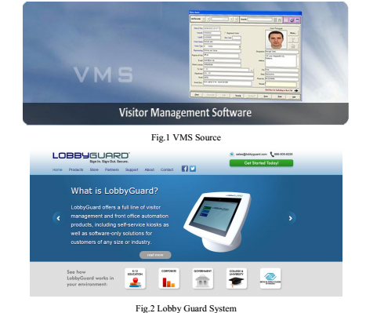
Lobby guard Kiosk system has helped the school organization in savings its time at the same time the student’s safety is not at risk. The above Fig.2 shown the lobby guard system for school visitors. Functionality provided by the system has helped the organizations in saving the time of its employees otherwise they had to attend to the visitor at the entrance whenever a new visitor arrives. The organization is exited with the features offered by the system since it saved employees time and takes care of the student’s safety (LobbyGuarD, 2013).Installation of the system creates an impression to the visitor that safety is the top priority for the organization.
The system takes care of the sign-in process which is streamlined by powerful solutions offered by the system. The system tracks every visitor who enters the school premises. Sing-in and sign-out process is tracked by the system with other details such as whom has the visitor come to meet with reason for the visit(LobbyGuard,2013).Happy Visitor Management system manages all the activities that are involved in managing a visitor Fig.3, the
system developed using cloud computing. The main idea of the system is to make the visitor an easy activity making it a trouble free visit (Happy visitor, 2014).

2.6 EXISTING SYSTEM OF GATE PASS MANAGEMENT SYSTEM
Currently, in many organizations and companies Gate entry is controlled by two main gates. Guest access by car requires gate pass form signed and faxed to Organization Security office by the inviting person. This is not an efficient way and reasons are pretty simple. In some organizations, even in this modern era Gateman/ Guard using registers to the entry about person or vehicle. Which means, no authentication is done by Guard and which result in many miss happenings.
The problem with the current system:
Any fax owner worldwide can issue a gate pass. Which results in undesired people or vehicle entry in companies’ premises.
There is no control over the guest arrival. Anyone willing to enter can enter in the company. It may be possible some criminals may enter and park their vehicle in company parking area and police start asking a question to guard and they are helpless.
There is no way of knowing who and when and by who was invited. Regarding in register does not mean that information is true. There is no authentication process.
The project in the topic will replace the current tax policy and register entry by sophisticated Intranet system to overcome the above problems. Noting data in the register is very laborious works as well as time-consuming.
But New Gate Pass System replace the existing system and make the process faster.

2.7 APPLICATION AND DATA SECURITY OF GATE PASS MANAGEMENT SYSTEM:
All interdepartmental interfaces will have proper authentication and authorization to act upon the data made available to them. The login will be through secure sessions and over secure https protocol.
Major Modules
- Administration Module of gate pass management system
This module is normally used by the administrators at different departments who deal with the administrative work of guests on behalf of the host.
This web application helps the department representatives to register the expected visitor online, process the visit and pass on the information to the security.
Security and debt. can view the reports of the visitors for the date range. The dept. the administrator can fill in secondary data for the visitor and also generate reports and initiate other interdepartmental communication for coordinating/facilitating arrangements.
- Security Gate Module of gate pass management system
The Security Gate module facilitates the admin staff at the security gate to register the visitor’s arrival with photograph and send the notification to the host.
The system can take in secondary real time data about the visitor, his co-visitors, and belongings. Check-in and this interface Module processes check-out.

2.8 Advantages of Gate Pass Management system
There are many advantages of Gate Pass Management System. This online system helps the service providing company to manage their Gate Pass remotely. Guards are finding everything about Gate Pass with few clicks.
The new system is the totally computerized system.
- User Satisfaction Level:
This online system gives each and every service to visitors Gate Pass just by giving some information.
- Time efficiency:
A new system provides features like time efficiency to show Gate Pass, Guards details etc.

Various type of Service:
This system provides view Gate Pass, Person details, vehicle details just after few click.

Easy Inquiry:
An inquiry is easily done by the user in the system. The inquiry is basically automated and computerized task which really makes inquiry process faster than previous. About Gate Pass related query.

Infrastructure:
It is an online based application. So, it does not require a big infrastructure. This system can be run just add it to the main system because our main dealing with Gate Pass is online.

2.9 Future Enhancement Of Gate Pass Management System
In near future, we are planning to use more sensor to automate the process of gate pass. Which will help to make the process less time-consuming?
We are planning to add new feature i.e. to get a gate pass instantly.
We are working to increase automation in the system to increase user experience great.

.

CHAPTER THREE
RESEARCH METHODOLOGY
3.1 DATA MODEL USED:
A. System Development Life Cycle (SDLC) Model
In this study, the development model of VGMS application software there are five phases involved: Planning, Analysis, Detailed System Design, Implementation and Maintenance. Figure 2 illustrate SDLC model that have been used in VGMS development.
The first phase of SDLC is planning in which the team is required to conduct meetings, initial information and feasibility study. Meanwhile in the second phase, which is analysis, user requirement is to be studied properly because it helps in overall SDLC. Evaluation of existing system and conduct logical system design need to be done. Furthermore, under the third phase
detailed system design is carried out by team mates based on the first and second phase input. After the completion of first three phases the team members proceed with system coding, testing and debugging of the system. To ensure that the system works according to the requirement of the user and suitability of the environment installation of the system is performed. The last phase is the maintenance phase in which the system is observed and maintained. If any additional requirements are demanded by the end user then according changes are performed over system in this last phase.
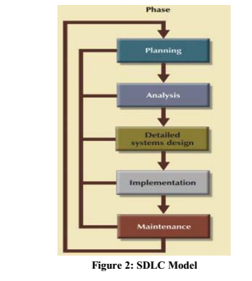
3.1.1 Overview of the model used:

VGMS is a Web application, which has all the information about visitors to the Organization. Every visitor has a mandatory host who is a employee. Each visitor has a unique visitor ID and a visit ID associated with him / her. System logs and tracks each visitor and visit and also facilitates the processing of Visit. Also it is the authentic record for Security staff on Visitors to
the institute. The Visitor Gate-Pass Management System (VGMS) is an integrated system for handling visitors3.1 which automates the workflow involving the host, admins, general administration, security and academic and non-academic visitors. The VGMS
has been designed after studying the current workflow concerning visitors in the Institute. It is designed to simplify the administration and thereby provide a minimally intrusive experience to the visitor and the host.
The VGMS will set up three classes of visitors: long term visitors, intermittent visitors and short term visitors.
Long term visitors are issued ID cards, and like all valid recognized ID card holders (e.g., institute members) will have minimal interaction with the security at the gate. The VGMS is an on-line simplification of the present system of internal emails and paperwork that accompanies the setting up of such a visit. It is envisaged that intermittent visitors (such as person who has temporary work for over a certain project in organization) be issued temporary ID cards of limited, but long-term, validity (such as 4 months). A valid ID card of this kind will allow visitors to have minimal interaction with the security at the gate. The VGMS is designed to simplify the workflow that will be required to initiate the process of requesting such ID cards. The remaining category, of short term visitors, consists of people who will continue to have to record their entry and exit into
the organization, as they do now. The VGMS is designed to simplify the workflow surrounding such visits.
• Visitor Classification
1. Short term Visitor is a visitor whose visit does not span a night. STGV is a specific class of ST visitors, where there will be Group lead's identity for the group members.
2. Long Term Visitor is a visitor whose visit duration spans more than a night.
3. Intermittent Visitor is one who frequently visits organization on a regular basis for considerable duration of say a few months.
• Broad Categories of Visitors
From the application point of view, the under mentioned visitors will fall into either
Long term, Short term or Intermittent visitor
- Collaborative research / Academic Visitors – Long term
- Day visitors – Intermittent Visitor
- Visitors from other organization – Transparent to gate and system (Self ID)
- Daily wages staff - Intermittent Visitor
- Contractors staff – Intermittent Visitor
- Suppliers / Vendors - Short Term Visitor
- Visiting Police - Short Term Visitor
- Courier Personnel - Short Term Visitor
- Tender related Visitors – Short Term Visitor
- Group Visitors – Short Term Visitor
3.1.2 Types of visit:
- Planned & Official
- Unplanned & Official
- Planned & Unofficial
- Unplanned & Unofficial
• Entities Involved
- Visitor
- Employee
- Organization
- Security Personnel
- Admin
• Features included
- Web application for Visitor & Visit management
- Target users – Visitor, Host & Security Staff
- System design is mainly based on Visitor Classification.
- Visitor details and photo maintained with a unique visitor ID with provision for partially planned visits. (Source is known but the exact name is not known for the visitor.)
- Administrative processing of the visit for the visitor by Host concerned.
- Notification of visitor’s arrival to host and security.
- Customized Entry Pass for different visitor categories with photograph
- Alerts for gate pass not returned at the security gate
- Generation of email alert to security officer for foreign visitors
- Grey-listing for some visitors with associated reason.
- Report generation on visitor and visit data.
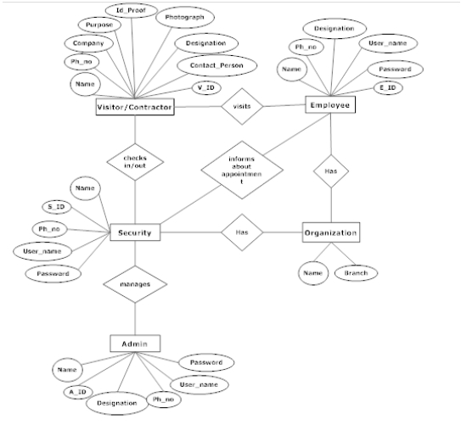
- Different entities have limited edit / view access, only to data, for which they are authorized to access and act upon.
.

Figure 3: Enhanced Entity Relationship diagram

3.3 DATA ANALYSIS
A. Data Classification
- 1. Primary data: This is the data for which the visitor is the owner and hence the authentic source. E.g. Profile information, Permanent contact details, Visit Details.
- 2. Facilitating data: This is the data fed by the institute departments interacting with the Visitor Information System to facilitate the visit. E.g. Local contact details.
- 3. Secondary / Real-time data: This is the real-time data fed/updated in the system by the security personnel. E.g. Verification of Laptop make if the data is already fed in.
B. Data Manipulation
Under no circumstances primary data can be altered by anyone other than visitor. The administrator can lock the data once he/she is convinced that the primary data entry is over. Once a record is locked, even if the visitor wants to change the primary
data, the administrator permission has to be sought to open the record again for editing.
C. Data Privacy
Since the application has all sensitive and personal information regarding the visitor, data privacy is utmost important and is taken care of. The data in totality is not made available to any entity other than the Visitor Information System administrator to even view. Organization staff who have access to the system have access to only that part of the visitor data which they need
to know about and also on which they need to act upon. No other entity interacting with the system. For a full list of entities involved in the system operations, please refer to the Entities Involved Section.
D. Data Ageing & Storage / Removal
Data belonging to a long term visitor is more sensitive and hence this data has to be properly aged and stored securely. The data can expire alongside the date of expiry and post-expiry the data has to be stored securely and has to be protected against leakage and tampering. For Short term visitors and intermittent visitors, data can expire in two years.
E. Application & Data Security
All interdepartmental interfaces will have proper authentication and authorization to act upon the data made available to them. The login will be through secure sessions and over secure https protocol.
F. Major Modules
• Administration Module
This module is normally used by the administrators at different departments who deal with the administrative work of guests on behalf of the host. This web application helps the department representatives to register the expected visitor online, process the visit and pass on the information to the security. Security and dept. can view the reports of the visitors for the date range. The dept. administrator can fill in secondary data for the visitor and also generate reports and initiate other interdepartmental communication for coordinating / facilitating arrangements.
• Security Gate Module
The Security Gate module facilitates the admin staff at the security gate to register the visitor’s arrival with photograph and also send the notification to the host. The system can take in secondary real time data about the visitor, his co-visitors and belongings. Check-in and Check-out are processed by this interface Module.
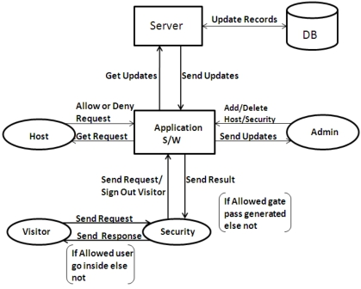

Figure 4: System Architecture
Module Description
- Appointment Module: This module is for setting appointments of visitors
- Security Module: This security module is installed at entrance of the premises or organization
- Host Employee Module: The host employee can check the visitor details on web pages
- Purposed Solution Architecture
Steps of Operation
- Appointment Generation by Office Employee.
- Security checks visitor’s panel, if appointment exists a Webcam captures the photo of the visitor at the entrance, the reception or security person enter the details of the visitor or Pre-scheduled appointment is displayed.
- Information / message is sent via SMS to the officers PC by sending visitor details & photo, and wait for his approval.
- Officer decides to meet or forward or refuse the appointment or ask to wait.
- If approve then software prints the Pass for visitor.

3.4 Functional Specifications of Gate Pass Management System

3.4.1 User Specification of Gate Pass Management System
- Admin:
Admin is basically super user. Admin can add a record of manager, Guard, can approve a gate pass, restrict the entry of any person or vehicle. Admin will keep track of each Gate pass. Manage organization Security.Admin is responsible for any error in the system. So, he needs to get altered at any point of time. Admin should keep tracking each person and vehicle entering company premises.
- CSO:
The manager is part of an organization who is dealing with each guard. The manager needs to keep track of guards and area under his supervision. The manager can view entry gate details, Guard details, approve a gate pass, manage gate passes.They will see any unwanted activity restrict the entry of person or vehicle.
- Guard:

Guard is the basic unit of Gate Pass Management system. Guard can view entry gate details, whether a gate pass is approved or not. They would allow only if gate pass is approved.They will see any unwanted activity restrict the entry of person or vehicle. Guards are there to just follow the instruction given by higher authority via GPMS.

3.5 E-R Diagram Of Gate Pass Management System
Once the planning and analysis of the project are done, the design phase begins. The goal of system design is to transform the information collected about the project into the blueprint structure which will serve as a base while constructing the system. It is an unwieldy process as most of the errors are introduced in this phase. However, if an error gets unnoticed in the later process it may become difficult to track them down.
The following entity-relationship diagram shows the graphical view of required components of the system.

Properties:

Admin: Primarily, the user which will interact the system will be the administrator of Organisation Responsible for security who is assigned to take care of all data transaction and insertion or update.
It will have to go through an authorization process of login and logout. It will have the ability to add Guard details, view Gate pass, add/edit Manager information and take care of development and maintenance of application

Name: Name of Admin which required to identify the person in charge.

AdminID: It will be a unique value which will act as the primary key and will be same as employee id in the company.

EmailID: For contacting purpose every user must enter their email id.

Address: Employee address is also an attribute which helps to get more about the employee.

DoB: Date of birth helps to get information about age and which also helps to get the experience of admin.

Manager: Secondary, user which will interact the system will be Manager. It will have to go through an authorization process of login and logout. The manager can view entry gate details, Guard details, approve a gate pass, manage gate passes. They will see any unwanted activity restrict the entry of person or vehicle.

Name: Name of Manager who is in charge of the office for security management.

Manager_ID: It will be a unique value which will act as the primary key. It will help our table to get details of manager whenever admin wants to get information of any manager.

EmailID: For contacting purpose every user must enter their email id.

Address: Manager Address is also an attribute which helps to get more about Manager.

DOB: DOB would be used as criteria for a discount. Senior citizens get more discount.

Guard: Another user which will interact the system will be Guard. It will have to go through an authorization process of login and logout. Guard can view entry gate details, whether a gate pass is approved or not.
They would allow only if gate pass is approved. They will see any unwanted activity restrict the entry of person or vehicle.

Name: Name of Guard who is part of security in office for security management.

Guard_ID: It will be a unique value which will act as the primary key. It will help our table to get details of Guard whenever admin wants to get information of any guard.

Mobile No: For contacting purpose every user must enter their phone no.

Address: Guard address is also an attribute which helps to get more about Guard.

Gate Pass: This table is the main table in our database which keeps record of each entry with personal details and vehicle details. This will help to get and track of every entry and exit in our organisation.

GatePassID: This is the primary key to Gate Pass table. This ID would tag with every person or vehicle. This would help to get Gate Pass details using this ID.

EntryTime: This field holds the information about entry time of person or vehicle.

ExitTime: When a person or vehicle leaves company premises. Its details should be updated.

InvitorID: This is in by whom visitor has been invited or allowed to enter on company premises.

PersonID: It is a foreign key for Person details table. PersonID contains an ID which refers to personal details table and has full details of the person.

VehicleID: It is a foreign key to vehicle table and which to tag vehicle details to Gate Pass table.

Vehicle Details: Vehicle table stores data about the vehicle in the database. As this system is all about Gate Pass service.

Vehicle_ID: Every vehicle has its own and unique ID which help to identify each vehicle uniquely.

Vehicle Registration Number: This is the number given to each vehicle by Government. This means we have the official record we use which will help the customer to travel without any problem.

PersonID: Every vehicle has its owner and this field helps to find the owner of the vehicle.

Person Details:
This is table adding information of person visiting the company or organisation. This will help to get true information of person visiting company.

PersonID: This is same as ID in Gate Pass. This is the primary key to this table. This ID helps to identify each person uniquely.

Name: Person name is the name of the person visiting company.

Contact No: For contacting purpose every user must enter their phone no.

Address: Person address is also an attribute which helps to get more about Person visiting company.

3.6 User Interface Design of Gate Pass Management System
UI plays a major role in the success of any software. Simple, user-friendly and standard UI makes visitors experience great and which means the software is going to be successful.
Sometimes very smooth and has very good database design software can’t able to make their existence in the market because of it UI.
The Gate Pass Management System hassles out all the complication of conventional method which is a combination of the interaction to human. Each profile has its own UI which is customized by our experienced team to make them feel like they are special.
We have developed very simply, User-friendly UI with all standardization. Followings are the interfaces

Login Page:
Basically, for any software security is a major concern. So, we have developed a secure application. Without being authenticated no user is allowed to view any other interfaces.
For login page, we have User ID, Password, Profile. After being authenticated user is authorized to perform certain work according to his/her profile.

Profile Page:
Every user has his own profile. From here they can change their information like a correction in name, email id, address etc. In our system, there are three profile i.e. Admin, Manager, and Guard.

Admin Page:
This page basically meant for admin profile. Admin has all manager details on his page. He can edit and add a new manager, view all guard’s details, can edit, or remove the guard details.
Whenever guard adds or any request from another member of the company for gate pass, Admin can approve the request of Gate Pass. Admin has all right to reject any gate pass entry if any suspicious person or vehicle want to enter on company premises.

Manager Page:
Managers are basically managing to guard and vehicle parking coming to company premises. Manager’s deals with guard duty, parking area, track the record of expiry of gate pass, handle query and any conflict with staff and visitors.

Guard Page:
Guard profile is a tag to every guard working for the organisation. They can edit their personal information, mark their guarding place, view the gate passes, add information to gate passes, report gate passes in case of any suspicious activity. Management would take care of rest.

Gate Pass page:
Gate pass page is page meant to request gate pass by organisation. Gate pass required the information like Person details, vehicle information, entry time, valid till, etc.

Exit Protocol
- Collect the Visitor & Co-visitor(s) Pass & ID card
- Update Exit information (Secondary data).
- Update Checklist of returnable equipment
- Security Gate Protocol for Short Term Visitors
- Reclaim the Visitor & Co-visitor(s) Pass & ID card
- Update Exit information (Secondary data).
- Update List of returnable equipment

Entry Protocol
- Inform and confirm with the host (if the visit is unplanned)
- Capture Image &create Visitor Pass & Co-visitor(s) pass
- Update Visitor Entry information
- Update List of returnable equipment (Secondary data)

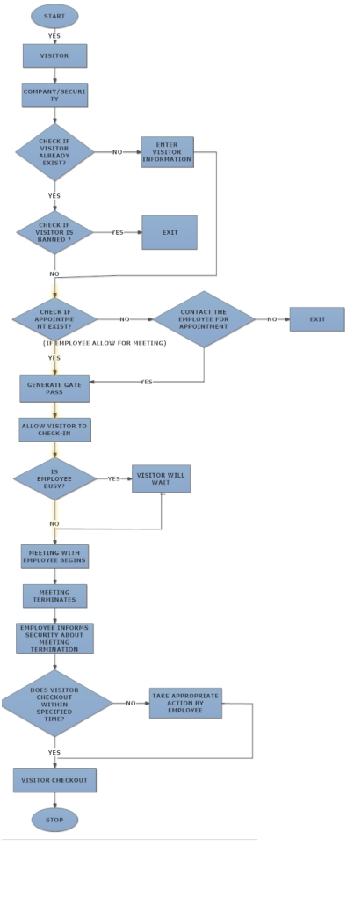

3.5 SECURITY GATE PROCEDURE OF GATE PASS MANAGEMENT SYSTEM
Security Gate Protocol for Long Term Visitors

Entry Protocol
- Cross check system data with identity credentials.
- Deliver the Welcome Kit (containing ID Card, Wireless User id & Password) to visitor
- Update Visitor Entry information
- Update Checklist of returnable kit (Secondary data)
FEATURES OF THE NEW SYSTEM
- Multi location, Multi department, Multi User system.
- 3 main user profiles for visitor management i.e. admin, host-employee & security/receptionist.
- Easy to use interface.
- Role-based user login.
- Manage multiple host employee data.
- Add appointments, set banners, messages.
- Manage Visitors through pre-approved list, watch list, ban list.
- Scan a visitor through pre-approved list, watch list, ban list using image.
- Inform Host Employee about visitor arrival through Email/SMS /Pop-up messages.
- Design customized Visitor Gate pass (Contract/Regular).Can create & store multiple gate-pass profiles. Various detailed and summary reports of Security wise, Host - Employee wise Visitors, banned visitors, Visitors in Watch list etc. Reports can be exported in various formats like Word/ Excel /Pdf etc.

CHAPTER FOUR
SYSTEM TESTING AND IMPLEMENTATION
  - Introduction
System implementation is the stage of a project during which every theory is turned to practice. During this phase, the developed software is loaded on a dedicated server.
4.1 Choice of Programming Language
This project is implemented with the following programming languages.
- PHP
- XHTML
- MYSQL
- APACHE SERVER

PHP (Processor Hypertext): It was considered suitable or this project because it is a powerful server side scripting language for creating dynamic and interactive website. PHP is a widely used, free and efficient alternative to other competitor scripting language such as Microsoft ASP. PHP is perfectly suitable for web development and can be embedded directly into the HTML code. It is often used together with Apache (web server) on various operating systems. It also supports ISAPI and can be used with Microsoft IIS (Internet Information System) on windows. Scripts in a PHP file are executed on the server that is why it is more sophisticated than other programming languages. It runs on different platforms, (windows, Linux, Unix etc).
MY SQL: MYSQL is a database server that is ideal for both small and large applications like the project of this type. It supports standard SQL and it compiles on a number of platforms
APACHE SERVER: This is used to deploy the on-line site.
4.2 Output Specification and Design
The output design was based on the inputs. The report generated gives a meaningful report to the management. The system designed generated the following reports.
1. Security Information Report
2. Police Report
These outputs can be generated as softcopy or printed in hard copy.
4.3 System Requirement
The system requirement are categorized into four namely Hardware requirement, software requirement, operational requirement and personal requirements.
4.3.1 Hardware Requirements
- Storage – 40 GB and above
- RAM – 1GB and above Memory – 256MB
- Display – 15 inches of monitor
- Optical Device Drive – CD drive
4.3.2 Software Requirements
- Storage – 40 GB and above
- RAM – 1GB and above Memory – 256MB
- Display – 15 inches of monitor
- Optical Device Drive – CD drive
4.3.3 Operational Requirements
- A flat table
- A chair that supports method of agronomy

4.4FUNCTIONAL DIAGRAM
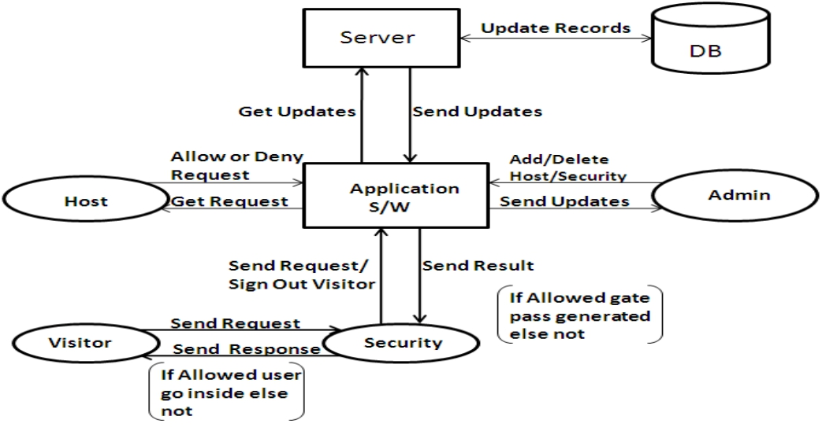

Appointment Generation by Office Employee.
- Security checks visitor’s panel, if appointment exists a Webcam captures the photo of the visitor at the entrance, the reception or security person enter the details of the visitor or Pre-scheduled appointment is displayed.
- Information / message is sent via SMS to the officers PC by sending visitor details & photo, and wait for his approval.
- Officer decides to meet or forward or refuse the appointment or ask to wait.
- If approve then software prints the Pass for visitor.

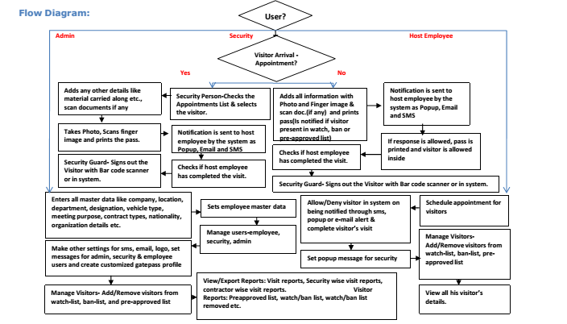

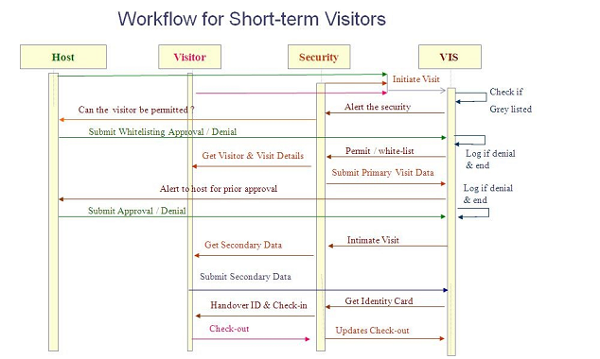

Workflow for Short term visitor
• Visitor / Security personnel fill in the visitor details in a web-form.
• System checks for grey-listing of visitor.
For a known grey-listed visitor, security is prompted to verify with the host by providing the reason for visitor grey listing and seek prior permission before letting in the visitor.
• For an unplanned visit, on alert from security, the host verifies the data. The alert medium is a combination of email & telephonic contact.
The host is contacted by email and telephone.
Wait for a maximum of 10 minutes for response from host
Response
• Host sends the response on the application OR Security
receives a response telephonically.
• Host / Security update the system for visit confirmation /
rejection.
No response
o The dept. secretary is contacted by email and telephone.
o Wait for a maximum of 10 minutes for response from dept. representative.
♣ Response
• Representative sends the response on the application OR
Security receives a response telephonically. • Representative / Security update the system for visit
confirmation / rejection.
♣ No response
• Visit denied.
• Host-verification and acceptance process is completed. • The system opens up to the feeding of secondary data, if any required, which the security personnel fills in at the real time of guest arrival. • The security can get a print out of the ID card and give it to the visitor and check in the visitor. The visitor status is marked as “IN”. • When the visitor completes the visit, he/she has to surrender the ID card. Security personnel can update check-out and visitor status is marked as “OUT”.
Group Visitors
These are planned ST visitors... From the application point of view there will be a
group identifier flag which gives the information to the system that this visitor
though short term is a group visitor.
1. Generation of IDs before Visit during the visit lead time.
2. All group members identified with reference to the Group head with a numeric of
headcount. e.g. VJTI999 – Group Visitor ID
3. Only host approval required here.
4. Time in, time out recorded.
5. Concerned dept. interface and security will have the data about the group visit.
6. Any activity of a group member is the responsibility of the group lead and he/she
will be answerable and accountable for the entire group.
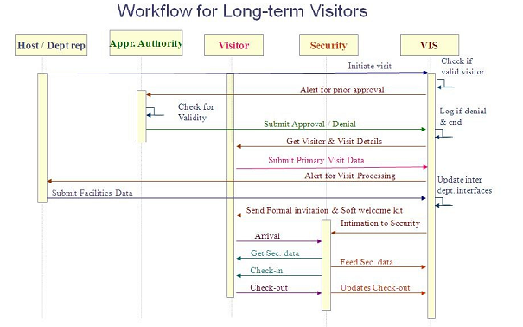
Workflow for Long term visitor
• Dept. representative / Host fills in minimal details in the visitor intimation web
form.
• The visitor and visit data is mailed to the concerned authority for proper approval
of the visit.
o If duration of visit < 7 days, dept. chair is the approving authority
o If duration of visit > 7 days, dean is the approving authority
• The authority can confirm / reject visit. Rejected requests are logged and visit
processing ends.
• If the request is accepted, system sends an email to visitor to fill in the primary
details.
• Visitor fills up the Visitor Form. The fields where the visitor has authentic
information are editable by visitor only and not anyone else. This phase should
have the provision to accept offline processed visits also and proceed online from
here. • Host verifies the primary details.
• On receipt of primary data, the dept. representative is alerted to take care of the
other formalities like office space allocation, stay, travel arrangements etc.
• All related departments process the visit data and update the system with
facilitating data for visit.
o Mail a form with Details to Establishment for Honorarium
o Printable form to Dispatch for ID card
  - Interface Design
Upon successful installation and launching, this is the first module (activity) that pops up in the application. This activity is the Welcome Activity. The user does not need to do any kind of interaction with this module, it’s just an animation activity that lasts for 3 seconds before the second module (activity) is loaded i.e. the Home Menu Activity.
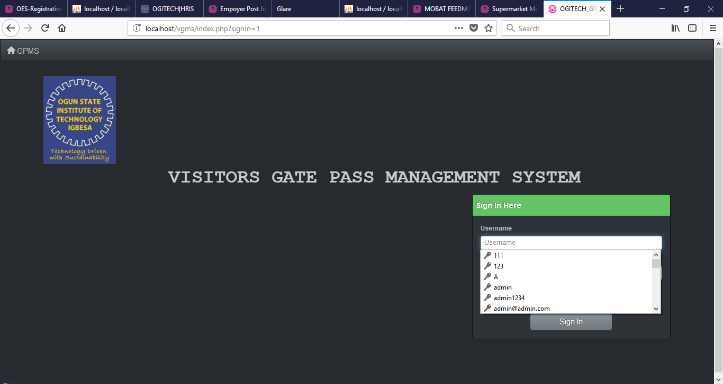
Figure 4.5.1 homepages

    - main menu
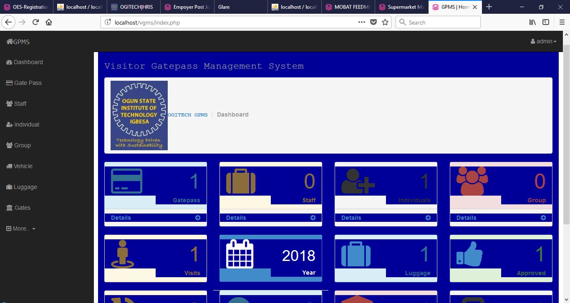
Figure4.5.2-main menu

    - gate pass form:
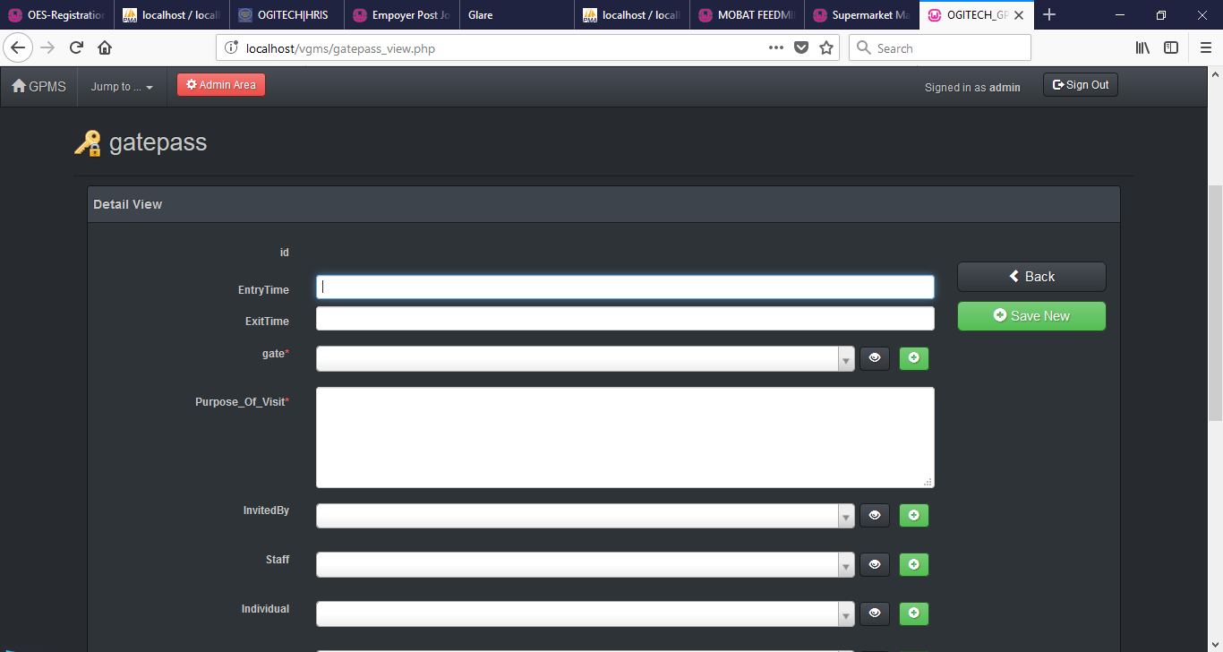
    - add staff form
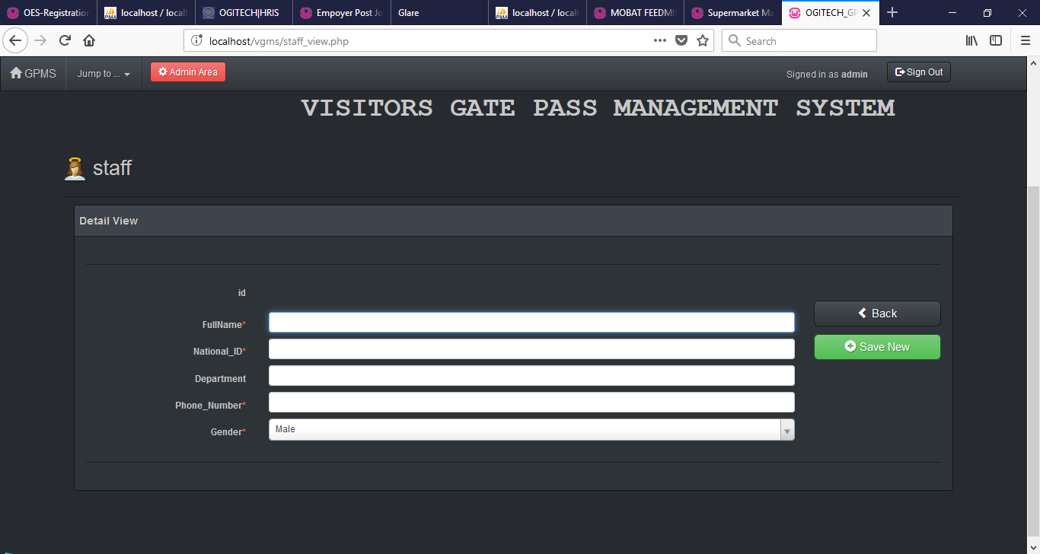

    - add group visistor page
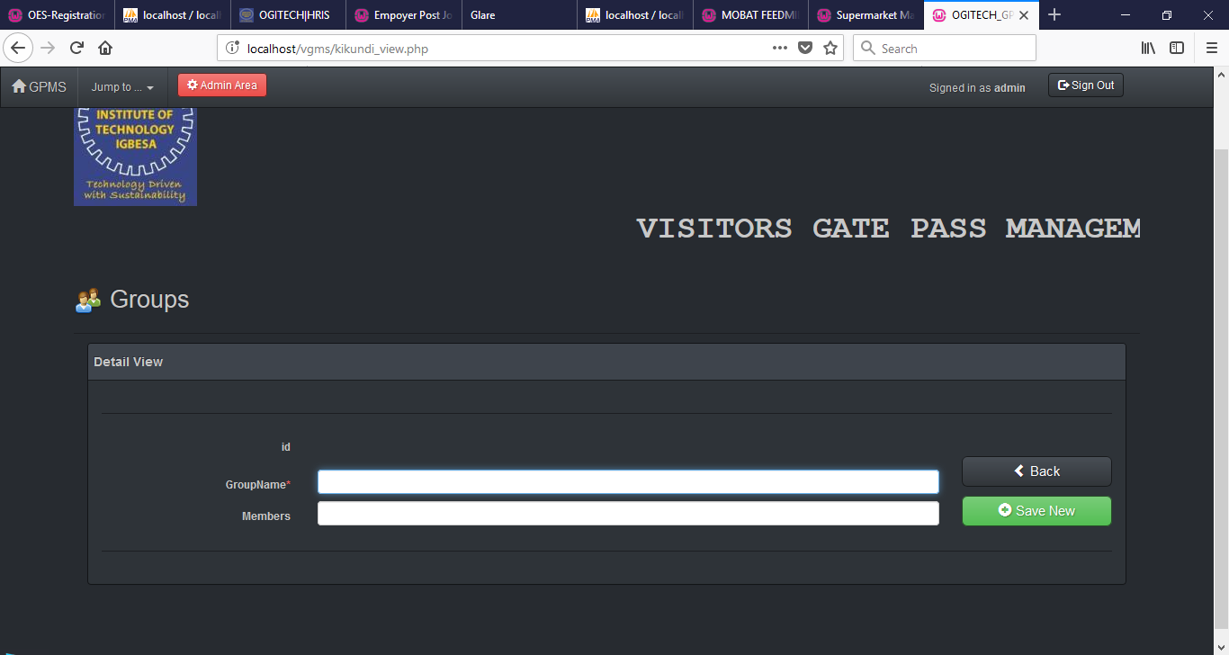

4.5.6- add vichele form
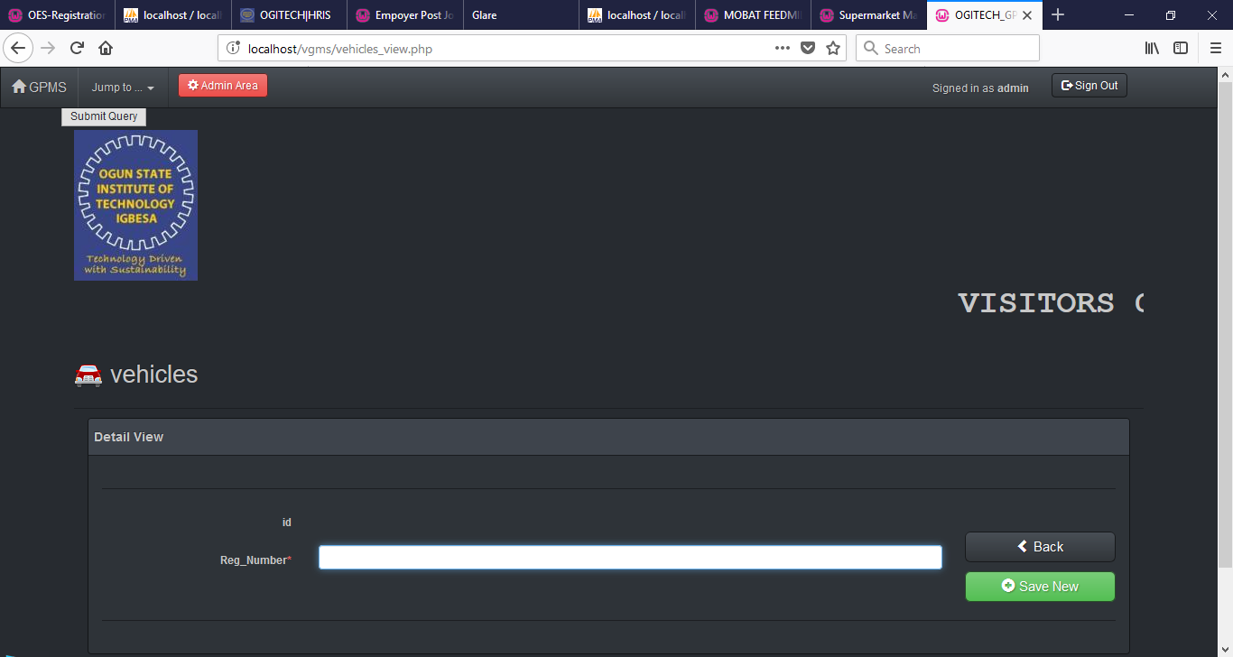

4.5.7- add luggage form
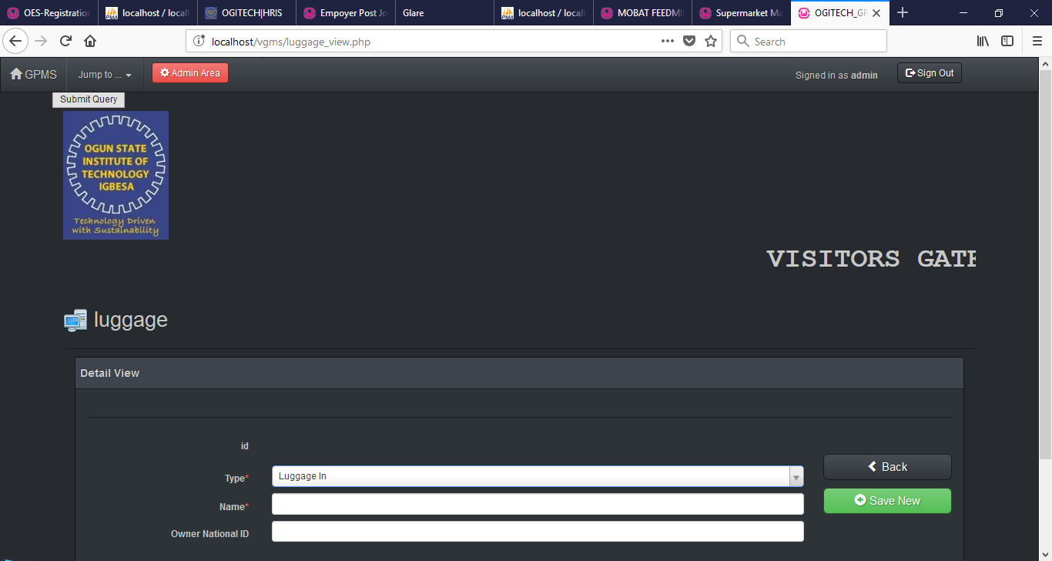

CHAPTER FIVE
SUMMARY, CONCLUSION AND RECOMMENDATION
  - SUMMARY
Information in its most restricted technical sense is an ordered sequence of symbols that record or transmit a message. It can be recorded as signs, or conveyed as signals by waves. Information is any kind of event that affects the state of a dynamic system. As a concept,
However, information has numerous meanings.
Moreover, the concept on information is closely related to motions of constraint, communication, control, data, form, instruction, knowledge, meaning, mental stimulus, pattern, perception, representation, and especially entropy.
5.2 RECOMMENDATION

5.3 CONCLUSION

The computer becomes important equipment to the organization to store the data and to process the data for any purpose. It also can be used to access and process any data and information needed easily and less in time. Therefore, it is hope that VGMS application system able to solve the problem according to these scopes:
• By using VGMS, the organizations have an option in increasing the level of security enforced in their premises.
• VGMS enables free, secured, fast and easy visitor registration.
• Computerized records give better management and manipulation of data, through searching and report generation.
• Its installation is easy and hence does not require professionals for the same.
• The VGMS system is easy to maintain and use.
• It gives reliable and efficient security protection on which one can rely.
• Unauthenticated and unwanted users cannot enter the commercial space.
• Biometric functions can be coupled with the existing system to gain extra security.

Hence we can conclude that this system would prove to be an efficient system to obtain a Gate Pass in any organization. Using this system the usage of paper decreases drastically and gate pass can be obtained through SMS that proves to be more secure and easy process which also saves time in obtaining gate pass and thus makes procedure easy. Also higher authority can generate report directly from database rather than maintaining record of gate pass taken by each visitor „n ‟ times.

