ONLINE VOTING MANAGEMENT SYSTEM
(A CASE STUDY OF FUNAKAYE LOCAL GOVERNMENT)

BY

GROUP 14
S/N | NAMES | REG. NO
1 | MUHAMMAD UMAR ZADAWA | ND/CS/A/19/0195
2 | NASIRU ABDULLAHI | ND/CS/A/19/0352
3 | ELIZABETH MAGAJI | ND/CS/A/19/0205
4 | ABDULKADIR HARUNA DANDELE | ND/CS/A/19/0254
5 | MUHAMMAD MUHAMMAD JIBRIN | ND/CS/A/19/0294

A PROJECT SUBMITTED TO THE DEPARTMENT OF COMPUTER SCIENCE, SCHOOL OF SCIENCE AND TECHNOLOGY, GOMBE STATE POLYTECHNIC BAJOGA IN PARTIAL FULFILLMENT OF THE REQUIREMENT FOR THE AWARD OF NATIONAL DIPLOMA (ND) IN COMPUTER SCIENCE

MARCH, 2022

DECLARATION
We hereby declared that this work is the product of our research effort, under taken under the
Supervision of Mustapha Umar and has not been presented and will not be presented elsewhere for the award of ND certificate. All sources have been dully acknowledged.

S/N | NAMES | SIGNATURE | DADE
1 | MUHAMMAD UMAR ZADAWA
2 | NASIRU ABDULLAHI
3 | ELIZABETH MAGAJI
4 | ABDULKADIR HARUNA DANDELE
5 | MUHAMMAD MUHAMMAD JIBRIN

CERTIFICATION
This is to certify that the project titled “Online Voting Management System was carried out under the supervision of:

_____________________________ ___________________
Name and Signature Date
(Project Supervisor)

_____________________________ ____________________
Name and Signature Date
(Head of Department)

______________________________ _____________________
Name and Signature Date
(External Examiner)

ACKNOWLEDGMENT
First of all, I give the glory to God and honor for everything he has done in my Life throughout the duration of my studies, I want to sincerely appreciate the effort of our supervisor Umar Mustapha, giving us the genuine advice during this Project, encouragement, moral and intellectual support. Kindness and comment Without which this project would not have been successfully completed I pray that the God almighty will prosper you in your entire endeavor.

DEDICATION
This project is dedicated to almighty God and other people that supported us from all angles.

ABSTRACT
Using electronic voting systems is divisive as some countries used such systems and others did not. Electronic voting (e-voting) is relatively a new concept based on its application that aims at reducing errors and improving the convenience and integrity of election process. This project tried to explore the factors that influence the adoption of such systems in a universal environment. Results indicated that public were keen on the concepts of trust and usefulness of e-voting when adopting such systems. Conclusions are at the end of this paper.

TABLE OF CONTENTS

DECLARATION ii
CERTIFICATION iii
ACKNOWLEDGMENT iv
DEDICATION v
ABSTRACT vi
LIST OF FIGURES ix
CHAPTER ONE 1
1.0 INTRODUCTION. 1
1.1 BACKGROUND OF THE STUDY. 1
1.2 STATEMENT OF THE PROBLEM. 2
1.3 SIGNIFICANT OF THE STUDY. 3
1.4 AIM AND OBJECTIVES OF THE STUDY. 3
1.5 SCOPE OF THE STUDY. 3
1.6 LIMITATION OF THE STUDY. 4
1.7 RESOURCES AND TECHNOLOGY USED. 4
1.8 DEFINITION OF TERMS. 5
1.9 ORGANIZATION OF THE STUDY. 6
CHAPTER TWO 9
2.1 THEORETICAL BACKGROUND 9
2.1.1 OVERVIEW OF E-VOTING 11
2.1.2 ATTRIBUTES OF GOOD E-VOTING SYSTEM 11
2.2 REVIEW OF RELATED LITERATURE 12
2.2.1 INTERNET VOTING 13
CHAPTER THREE 14
METHODOLOGY 14
3.1 INTRODUCTION 14
3.2 PRELIMINARY INVESTIGATION 14
3.3 FEASIBILITY STUDY 16
3.4 OVERVIEW OF THE EXISTING SYSTEM 17
3.6 OVERVIEW OF THE PROPOSED SYSTEM 18
3.8 SYSTEM DESIGN 18
3.8.1 SYSTEM ARCHITECTURE 19
3.8.2 SOFTWARE DEVELOPMENT LIFE CYCLE (SDLC) 19
3.8.2 RAPID APPLICATION DEVELOPMENT 19
CHAPTER FOUR 25
IMPLEMENTATION AND TESTING 25
4.1 INTRODUCTION 25
4.2 SYSTEM INPLEMENTATION 25
4.3 SYSTEM TESTING 27
Table 4.1: Testing Results 28
CHAPTER FIVE 29
SUMMARY, CONCLUSION AND RECOMMENDATION 29
5.1 SUMMARY 29
5.2 CONCLUSION 29
5.3 RECOMMENDATION 30
REFERENCES 31
APPENDIX A 34
APPENDIX A 38

LIST OF FIGURES
Figure 3.1: RAD Diagram. 20
Figure 3.2: UML Diagram. 20
Figure 3.3: Flowchart of the propose system 22
Figure 3.3: Flowchart of the propose system. 23
Figure 1: Register and Login Page 34
Figure 2: Pin Page provided from system administrator 34
Figure 3: Page for generating user pin 35
Figure 4: User Dashboard 35
Figure 5: Page for Casting Vote 36
Figure 6: Page for Confirmation vote 36
Figure 7: Page for showing the voting result 37

CHAPTER ONE

1.0 INTRODUCTION.
Election is one of the major obligations of Nigerian citizens, however many evidences of physical scenes, observation by election overseers and interviews with the election stakeholders and voters proven that there is no improvement in the voter turnout during elections. Although not all citizens can be able to cast vote during elections due to the age limitation, health issues or others genuine Personal issues, but many factors are proved to protest against the voter turnout projection. Some of these factors are lack of awareness on the importance and the impact of the elections, the heavy Logistics of the manual system of elections, and lack of the election and voter data integrity. In 2021, Kaduna state government conduct local government elections in an enhance way using electronic machines, and it was a success by the inferred statistics of the voter turnout, result integrity, time management. This means that there is need for all others Nigerian states to switch over from manual paper-based election system to electronic voting system (e-Voting System).

1.1 BACKGROUND OF THE STUDY.
Societies have conducted elections for thousands of years, but technologies used to cast and tally votes have varied and evolved tremendously over that time. In 21st century, much of our Communication took place online, and many people want elections to follow that trend. An
election is a formal decision-making process by which a population chooses an individual to hold public office. Elections have been the usual mechanism by which modern representative
democracy has operated since the 17th century. Henry (2011).
In March 2013, Overseas Vote Foundation’s President and CEO began a discussion with a small group of election integrity advocates to explore what they would do if faced with the challenge of defining an Internet voting system. Despite their concerns about the security of e-Voting efforts to date, they agreed that addressing this challenge is extremely central.
E-Voting systems provide some characteristic different from the traditional voting technique, and also provide improved features of voting processes over the traditional one such as accuracy, convenience, flexibility, privacy, verifiability and authenticity.
E-Voting system is an online voting technique used to conduct free, fair and authentic election with the aid of technology. We would provide a detailed description of the functional and performance characteristics of the e-Voting system. Voters can cast their votes from anywhere without visiting any voting ground, in highly secured way. Thus, it makes voting a fearless and free of violence and increases the percentage of voting.
Election process comes with many problems mostly related with human bias in handling the process or inability to oversee the activity to the end, other problems that mar the process include the volatility of data and insecurity, hence a need arise for finding a suitable system to handle such eventualities.
In view of the above, this project entitled “e-Voting System” is aimed at automating Funakaye Local Government voting processes so as to overcome the flaws associated with the current approach.

1.2 STATEMENT OF THE PROBLEM.
The process of conducting an election in Funakaye Local Government is manual. After critical examination of the manual system, it is observed that the following problems are associated with the System:
i. It takes too long to conduct an election.
ii. It is error prone in vote’s calculation.
iii. Conflict might be occurring as a result of one party may not accept the result.
iv. It is not easy to manage the election processes.
v. It is paper and pen-based oriented, etc.
In view of the above, a new system is proposed to overcome the problems associated with the current system.

1.3 SIGNIFICANT OF THE STUDY.
The integrated e-Voting system is designed to maximize the use of technology in our modern life in conducting an election in local communities. The system also makes a voting process Transparent to the indigenous people of the society in such a way that people can be able to see and confirm the votes they casted to the respective candidates of their choice. The use of paper will be significantly reduced to some extend by implementing the proposed voting system, if not totally eliminated. Also, there might be increased in number of voters as individual will find it easier and more convenient to vote, since it is online.

1.4 AIM AND OBJECTIVES OF THE STUDY.
The aim of this project work is to design and implement an electronic voting system that allow Indigenous people of Funakaye to conduct an election effortlessly with the use of modern technology and to increase awareness, reliability, efficiency, consistency and effectiveness.
The objectives of the system are as follows;
i. To efficiently store data in a very safe place to avoid loss of data.
ii. To provide an easy way to access data.
iii. To provide security and integrity of voter data.
iv. To reduce to the barest minimum, the processing time, access and retrieval of information
needed for speedy conduction of an election.
v. To reduce or eliminate disenfranchising electorates, etc.

1.5 SCOPE OF THE STUDY.
The scope of this research focuses only on how Funakaye Local conducts its election. The system is designed such that only authorized user can have access to cast his/her vote by presenting his/her local government indigene to acquire an election PIN which is going be provided during registration. The system can be accessed from everywhere provided that there is internet connection in the user current location. Each contestant must purchase pin from the election committee before he can register himself/herself as candidate. Each person must register an account on the system before having access to vote is granted, but this is required once.

1.6 LIMITATION OF THE STUDY.
The proposed e-Voting system achieved its own aim and objectives, even though there are some features that are not included in the system due to the inadequate resources. Some of these features includes:
i. Inability to send the election result to the voters via email or phone as a message
ii. This system will not provide statistics of the results for future inference.
iii. The system cannot be accessed where there is internet coverage.
iv. The issue of invasion is a big challenge of the web applications today. Like others, this
software is not free from hacking etc.
v. The software cannot be used directly by some legal users.

1.7 RESOURCES AND TECHNOLOGY USED.
To make the implementation of this project a job well done within the expected time slice, Rapid Application Development (RAD) model will be adopted for this work Hypertext preprocessor (PHP) Scripting language will be used for backend programming for the User interface design HTML5, CSS and Bootstrap 5 framework will be use and JavaScript for the User experience. Also to some hardware and software are used during developing this application including.
i. Visual studio Code.
ii. Xampp local server.
iii. Windows 10 operating system.
iv. Working station (personal Computer).
v. Internet.
vi. Mobile phone.

1.8 DEFINITION OF TERMS.
Bootstrap - Bootstrap is a free and open-source CSS framework directed at responsive, Mobile First front-end web development (Bootstrap Cheat Sheet 2021).
CSS- Cascading styles sheet. It is use for changing the view of the contents of the web page by applying specific or general styles to these contents (CSS Cheat Sheet 2021).
DonnorApp – an online platform for safe, healthy and free blood donation system. Election: is a process in which people vote to choose a person or group of people to hold an official position.
e-Voting: is an election system that allows a voter to record his or her secure and secret ballot electronically. Critics maintain that without a paper trail, recounts are more difficult and electronic ballot manipulation, or even poorly-written programming code, could affect election results.
GSPB – Gombe State Polytechnic Bajoga
HTML- hypertext markup language. The language for building the skeleton of a website or web
application.
JavaScript- JavaScript is high-level, often just-in-time compiled, and multi-paradigm. It has
curly-bracket syntax, dynamic typing, prototype-based object-orientation, and first-class
functions. JavaScript defines the behavior of a web page (JavaScript for Impatient Programmers
2021).
MySQL - is a database system used on the web.
Online – activity that is performed on the internet.
PHP - Stands for "Hypertext Preprocessor." (It is a recursive acronym, if you can understand what
that means.) PHP is an HTML-embedded Web scripting language (PHP Programming Cookbook
n.d.).
RAD- Rapid Application Development. Is a system development life cycle that heavily involve users in every phase and emphasizes more on development than fact finding.
Visual Studio Code: Text-editor: is a proprietary source code editor which is rich of plugins for enhancing coding productivity and speed.
XAMPP- is a free and open-source cross-platform web server solution stack package developed by Apache Friends, consisting mainly of the Apache HTTP Server, MariaDB database, and interpreters for scripts written in the PHP and Perl programming languages (XAMPP 2020).

1.9 ORGANIZATION OF THE STUDY.
This project is made up of five chapters and the contents of each chapter are listed.
Chapter one
This chapter includes the following
i. Introduction
ii. Background of the Study
iii. Statement of the problem
iv. Justification of the Study
v. Aim and objectives
vi. Scope of the Study
vii. Limitation of the study.
viii. Resources and Technologies Used
ix. Definition of Key Terms
x. Chaptalization
Chapter Two
This chapter includes Literature Review which contains the following.
i. Theoretical concepts and
ii. Review of Related Literatures (Existing Systems)
Chapter Three
Design and Methodology: this chapter should describe the methodology of the work done and should take into consideration the following.
i. Introduction
ii. Preliminary Investigation
iii. Feasibility Study
iv. Overview of the Existing System
v. Analysis of the Existing System
vi. Overview of the Propose System
vii. Analysis of the propose System
viii. System Design
Chapter Four
System Implementation and Testing: This chapter presents the result and interpretation of analysis of data collected; observation made on information gathered. This chapter consists of the following parts.
i. Introduction
ii. System implementation
iii. System Testing
Chapter Five
This chapter contains.
i. Summary
ii. Conclusion and
iii. Recommendation references and appendices

CHAPTER TWO
LITERATURE REVIEW

2.1 THEORETICAL BACKGROUND
This chapter gives a summary of is researched by other people. Therefore, it cites the relevant studies on e-Voting system, which involves the strength and limitations of the current system and related works.
The research on electronic voting (e-Voting) is a very important topic for the progress of democracy. E-Voting is the voting process held over electronic media. Traditional paper based voting can be time consuming and inconvenient. Electronic voting not only accelerates the whole process, but also makes it less expensive (reduced costs as the materials required for printing and distributing ballots as well as the manpower required to govern poll sites are considerably reduced).
Electronic voting technology can include punched cards, optical scan voting systems, specialized voting kiosks, etc. It can also involve transmission of ballots and votes via telephones, private computer networks, or the Internet Sandler (2015).
Since independence, Nigeria has been desirous of a credible voting system. Because of the irregularities that trailed the previous elections. Lack of accountability, probity and trust on the part of government has been responsible for the poor turnout during elections. The adoption of E_Voting has been considered long overdue because of the enormity of abundant human and material resources endowed the country Olateru (2007). In the developing countries, particularly sub-Saharan Africa and Africa in general, elections have been marred by gross irregularities leading to wanton destruction of lives and properties Helen (2005).
E-vote increases voter confidence and improves the voting experience. It also reduces the
chances of errors. I.e. reduces the number of legitimate votes not counted by reducing the
number of over-votes, and eliminating vote tampering Boutin (2004). In another research, the security issues associated with remote internet voting analyzed. In particular, the research examines the feasibility of running national elections over the Internet. The focus of this research was on the limitations of the current deployed infrastructure in terms of the security of the hosts and the Internet itself. It concludes that without appropriate security measures, internet-based elections can be a major challenge Ganiyu (2011). One of the most important government services like elections exerts pressure on people involved in that process, according to many constraints that must be applied to the beneficiaries of this service and which are divided into two parts, candidates and voters. Voting is an efficient method for the public to show their opinion about a given topic or issue Ogunseye (2010). The traditional election is normally held under the supervision of the government officials to assure the right application of the rules during the election process and to ensure that only eligible voters are permitted to join the election process avoiding any kind of forgery and the attempts of multi-voting. In addition, the process of human supervision over the election process requires a lot of efforts and money in order to achieve the desired level of privacy, security and trust.
A review was done of some of the problems and challenges of organizing and conducting an
election using the traditional Open Ballot System (OBS) with case study INEC, Kaduna. And
after the review of the manual system and electronic voting technologies, the project focused
on the question ―Is the internet voting sufficient for our voting processes and the work concluded that it is relatively impossible to develop an e-Voting system that will satisfy all
INEC specification of an e-Voting system. Then, developed an e-Voting system that is web
based and also advised that before the implementation of the system, the entire system should
be reviewed by INEC to ensure that it meets with The Design and Development of Real-Time
E-Voting System in Nigeria with emphasis on security and result veracity.

2.1.1 OVERVIEW OF E-VOTING
The term electronic voting has been used for a large variety of systems, ranging from handheld infrared devices, kiosk systems with touch screens machines used in polling stations to remote voting via the internet. E-Voting is the preferred platform for future elections in the developed and developing countries. The three types of e-Voting are:
i. Polling station e-Voting: where voters cast their votes on an electronic device within the
polling station.
ii. Kiosk e-Voting: where voters cast their votes at pre-selected stations through ATM-like
terminals.
iii. Remote e-Voting: voters cast their votes anytime and anywhere, so long there is internet
coverage, as well as voting through mobile devices.

2.1.2 ATTRIBUTES OF GOOD E-VOTING SYSTEM
i. Democracy: A system is democratic if it permits only eligible voters to vote and, it ensures that each eligible voter can vote only once.
ii. Accuracy: A system is accurate if it is not possible for a vote to be altered, it is not possible for a validated vote to be eliminated from the final tally, and it is not possible for an invalid vote to be counted in the final tally.
iii. Privacy: A system is private if neither election authorities nor anyone else can link any ballot to the voter who cast it, and no voter can prove that he or she voted in a particular
way.
iv. Verifiability: A system is verifiable if anyone can independently verify that all votes have been counted correctly.
v. Convenience: A system is convenient if it allows voters to cast their votes quickly, in one session, and with minimal equipment or special skills.
vi. Authentication: is distinct from authorization, which is the process of giving voters
access to system based on their identity. Authentication merely ensures that the voter is
who he or she claims to be, but says nothing about the access rights of the voter.
vii. Integrity: A system has integrity if votes can only be accessed or modified by those
authorized.
viii. Non-Repetition: guarantees that no repetition of any vote will be present in the final
tally (No voter is allowed to cast his or her vote more than once).
ix. Anonymity. Guarantees that the ballot does not indicate who do this voting. Secret
ballots are fundamental to democracy, and voting systems must be designed to facilitate
voter anonymity.
x. Speed: Voting systems should produce results quickly.
The success rate of an electronic voting system in electronic decision making is dependent on
security, authenticity and integrity of pre-electoral, electoral and post electoral phases of the
election process.

2.2 REVIEW OF RELATED LITERATURE
The voting system has experienced huge changes over years, traditional voting system which is also knows as electronic voting system using ‘EVM (Electronic Voting Machine)’ requires huge investment of time because of which people neglect voting. IEEE (2013) has proposed an architecture in which voting is done by making use of cards, these cards are designed similar to smart cards which have entire details related to the voter embedded in them. Hence, the proposed architecture in IEEE (2013) ensures security, verifiability and transparency in the voting system. The problem of this work was that, the process of making the election card to each individual voter was time consuming and costly. The system is very much beneficial for small scale setup such as for College and University elections or confidential recruitment. As explained by Ankit (2012), in order to overcome the drawback of electronic voting system, websites can be introduced which will help voters to remotely cast their votes. This study showed that voters cannot remotely cast their votes, but instead they must visit the election ground.

2.2.1 INTERNET VOTING
It is difficult to say whether online voting successfully increases voter turnout, Sal (2015) due
to the digital divide. A study conducted on “remote electronic voting and turnout in the Estonian 2007 parliamentary elections” Buhler (2010) showed that rather than eliminating inequalities, e-Voting might have enhanced the digital divide between higher and lower socioeconomic classes. People who lived greater distances from polling areas voted at higher levels with this service now available. The 2007 Estonian elections yielded a higher voter turnout from those who lived in higher income regions and who received formal education. Buhler (2010). Political parties that have more support from the less fortunate, who are unfamiliar with the Internet may suffer in the elections due to e-Voting, which tends to increase voting in the upper/middle class. It is unsure as to whether narrowing the digital divide would promote equal voting opportunities for people across various social, economic and ethnic backgrounds. In- the long run, this is contingent not only on internet accessibility, which is already widely available in Estonia, but also depends on people’s level of familiarity with the Internet Bochsler (2010).

CHAPTER THREE

METHODOLOGY

3.1 INTRODUCTION
This chapter will entail the methods of fact finding, system development processes; and study
the fate of developing system as well as deployment possibilities, system development life cycle(SDLC), overview and analysis of both current and proposed systems. In the course of this work suitable fact-finding techniques that will best march the development approach and the SDLC are worked in pair to ensure expected outcome at the end of this project. In this section the logical design of current and proposed system will be described. Some diagrammatic models will be use to show the transitions in the proposed system and how users of the system interactwith the system units.

3.2 PRELIMINARY INVESTIGATION
Success or failure of any system is determined by the end users. Usability of systems for the
end user decides whether software will be success or not. Usability is totally dependent on the
user’s requirements and these requirements are gathered from the users by elicitation techniques. The elicitations techniques are the base of any system development and different
methods are in use to gather requirement from users to enhance the quality of the software,
which in turn make it a success in software engineering. That’s why requirement gathering
process is very important in software development and it needs great attention of the developer.
Basically, uncovering user needs from the stakeholder is known as elicitation. The requirement engineering process is a set of activities for the collaboration, communication, prioritization relevant to the user. to make the implementation of this project precise and unambiguous, requirement elicitation methods that will best fit the work are chosen to put in place the project within expected timeframe, these elicitation techniques consist of Interview with stakeholders, Brainstorming session and physical observations.
Physical Observation
The basic procedure for conducting a democratic election is generally the same for any voting
system. Normally, this procedure involves four main tasks, that is, registering of eligible voters, validating voters’ credentials, collecting voted ballots and tallying the ballots. But it is observed that the above mention process makes election processes tougher and less integral, because on voting day, the ballot box is manually operated and not connected to the internet system.
Consequently, there is no way to access it remotely. Because of the higher population and the
advance in telecommunication versatility of the citizens, the need of enhancing the election
process is obvious, been advocated by many elections’ stakeholders. The drive towards
implementation of e-voting in Nigeria’s electoral process is gaining momentum, with expressed institutional commitment from INEC and manifested broad acceptance by a large segment of electoral stakeholders who see e-voting as the ‘silver bullet’ to enduring flaws that have consistently undermined the credibility and integrity of Nigeria’s elections (eces 2021).
Interview
The interviews with key electoral stakeholders and practitioners allowed to gauge expectations, level of consensus and state of play on the implementation of the e-voting including the level of acceptability, cost impact on elections, voter education requirements and other relevant issues that will emerge upon the implementation of the e-voting. To guide the discussion, some questions relating to challenges and solutions to effective implementation of e-voting were raised and examined within the context of the electoral environment, and sometimes comparing with how these issues were resolved in the case studies. This project adopted interview as one of the two elicitations methods in view of the work basis and its delivery schedules. An interesting fact about interview is that it can be done in person, through telephone, at work, at home, or at an agreed location. It also works best if the interviewer wants information straight out of the respondent.

3.3 FEASIBILITY STUDY
This Feasibility Study was conducted to evaluate the possibilities of introducing of modern
voting technologies in elections that will be conducted in Funakaye local government. Technical feasibility: to adopt any computer-based system of accomplishing a task the technical infrastructures both in hardware and software are mandatory to make difference.
Electronic voting can be well operated from both urban and rural communities in Funakaye
local government as citizens living in the local government have access to electricity and
internet coverage. However, some community’s do not have electricity supply but yet can be
access places to charge their phone and reserve the power for e-balloting as the system can be
access through mobile phones as well.
Economic Feasibility: Economic analysis is most frequently used for evaluation of the effectiveness of the system. More commonly known as cost/benefit analysis the procedure is to determine the benefit and saving that are expected from a system and compare them with costs, decisions is made to design and implement the system. This software will of course reduce the cost spent during elections processes.
Operational Feasibility: Deployment of remote voting requires some degree of literacy among the voters. Nigerian adult literacy rate defined as the percentage of persons aged 15 and above who can write a simple sentence in English was 62.02% in 2018 (eces 2021). This will impact the participation of a significant proportion of the population who may not also have access to devices to cast their votes either through mobiles phones or laptops.
Legal Feasibility: Is the Study to know if the proposed system is law abiding and matches the
legal requirements. In Legal Feasibility study, a project is analyzed in legality point of view.
This includes analyzing burdens to legal implementation of project, data protection acts, and
copyright. The system will be used by only registered voters and contestants, also it will be
maintained by the electoral commission. The system will be developed based on its primary
purposes. Hence, legally feasible.

3.4 OVERVIEW OF THE EXISTING SYSTEM
The existing system of conducting elections is manual. The voters an contestants are registered on some dates scheduled by the electoral commission, the elections materials are purchased earlier before the election day, Then elections materials are taken to the elections stands on day elections day, the voters and contestants are verified manually before casting their vote using paper based ballots, and wait until the elections are over to know the results, however it may happens sometime the result may not be announce at the distinct elections stands but at electoral commission office if any duress or treat is experienced at elections stands.
3.5 ANALYSIS OF THE EXISTING SYSTEM
The existing system being a manual, the users have their name registered in a book, the users
should be at the election stand exactly when polls commenced to listen to their names for
verification to vote. If user is not present or did not listen to his name, the official will move on to call other names, people who are not verified must wait until second round of voter’s
verification. All verified voters are recorded to avoid given someone mandate to vote twice.
After verification the voter proceed to collect the ballot paper and cast his vote. In manual
system all political parties send their argents to all polling units to observe the processes and
weigh behind the interest of his party.

3.6 OVERVIEW OF THE PROPOSED SYSTEM
The propose system has two units; the Administrator Dashboard and User Dashboard; the user can be voter or contestant. The Admin will issue pins to the user, approve the registration of all users and manage them. However, every user most login first to have access to his dashboard. The software will allow users to register and wait for the admin approval. It will allow user to register as voter or a contestant depending on the type of pin purchased, as well all user can be allowed to cast their votes if elections for which they are eligible to participate in started and can view result of the elections.
3.7 ANALYSIS OF THE PROPOSED SYSTEM
This system is a web based application that chance multiple people to use it at the same instance, on the course of this project an interview is conducted with the end users of the system – basically the voters on how the system should work, how the visualization of the system will be, and many others analysis inputs. The proposed is design to be user friendly and usable by all sorts of its users. The system allows users to register or login with their credentials if already registered to access their dashboards. On the dashboard navigation the functionalities granted to the student are precisely written and accessible by the users, including the logout link to exit session.

3.8 SYSTEM DESIGN
Design methodology refers to the development of a system. Today, the term is most often
applied to technological fields in reference to web design, software or information systems design. This has two basic units including the administrator unit who is responsible for managing the users and elections, the user units who has the mandate to register as a voter or
contestant. The software will follow Bottom up Design approach; a methodology that starts
from the foundation and works up towards a solution.

3.8.1 SYSTEM ARCHITECTURE
The architecture of system is split into two sides; the client side which contains the user interface, and the server side which contains the web pages were written by PHP and MySQL
database. By SQL queries that are written inside PHP pages can access the database. The
technologies were used in both sides were explained in more details in chapter four.

3.8.2 SOFTWARE DEVELOPMENT LIFE CYCLE (SDLC)
Like any project, for a software to be developed should be analyzed and outlined the purpose
of developing it, constrains behind developing it, and the benefits it will attract. After all analysis a certain way of constructing software that meets its requirement is inferred. SDLC
provides a well-structured flow of phases that help an organization to quickly produce highquality software which is well-tested and ready for production use. They may be linear,
incremental or evolutionary. The information required from the expected users’ true interviews shows that this project will be best accomplished if Rapid Application Development (RAD) is used, and in that regards the RAD model is adopted for the project.

3.8.2 RAPID APPLICATION DEVELOPMENT
Rapid Application Development is a linear sequential software development process model that emphasizes a concise development cycle using an element-based construction approach. If the requirements are well understood and described, and the project scope is a constraint, the RAD process enables a development team to create a fully functional system within a concise time period.
RAD (Rapid Application Development) is a concept that products can be developed faster and of higher quality through:
i. Gathering requirements using workshops or focus groups.
ii. Prototyping and early, reiterative user testing of designs.
iii. The re-use of software components.
RAD Model Diagram
Requirement
Planning

User
Description

Development

Total Switch

Figure 3.1: RAD Diagram.
Unified Modeling Language (UML) Diagram.

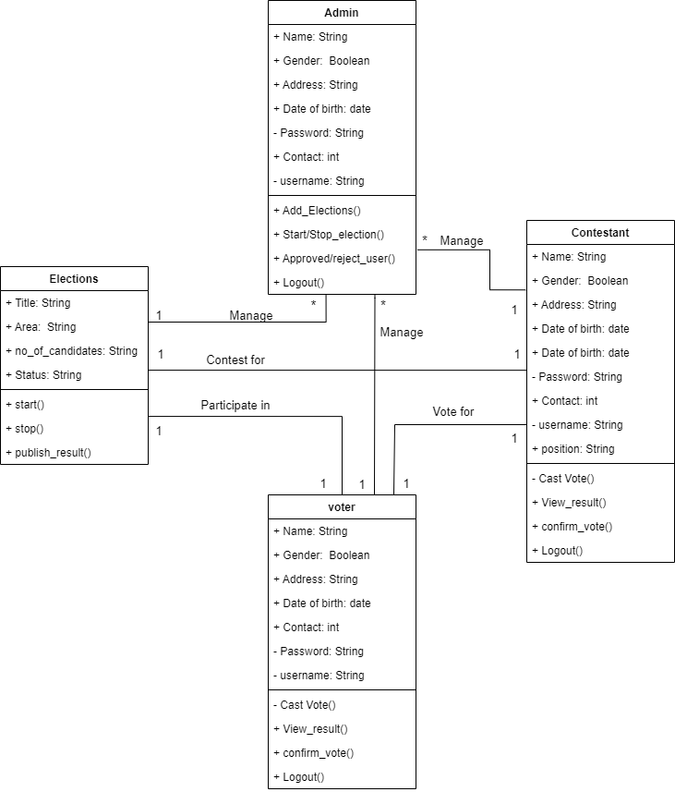

Figure 3.2: UML Diagram.

Design Methods
In this section graphical representations will be used to explain the logical flow of the system
and the physical. Will explain the modes of data transformation while the data moving through the system.
Logical Design.
In this part of the system representation a flowchart diagram is use to depict how user access the system and the functionalities granted for each user to access.

Flowchart Diagram of the proposed system
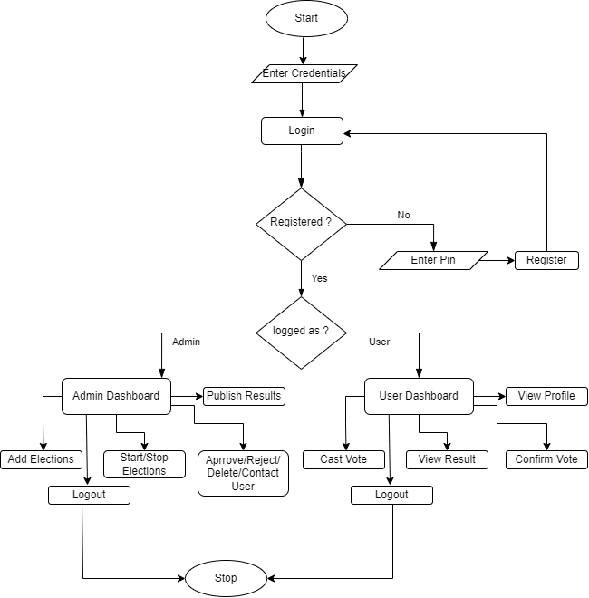

Figure 3.3: Flowchart of the propose system

Entity Relationship Diagram of the proposed system.

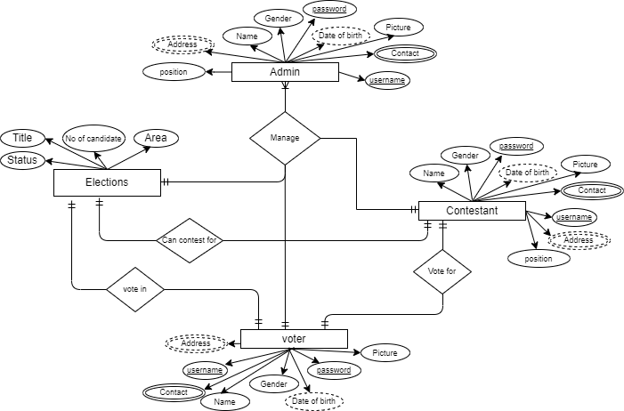

Figure 3.3: Flowchart of the propose system.

Physical Design.
The system takes information from two category of users; however, the is design to collect
specific data from each user, as explain below.
Adding information.
Admin:
The admin of the system is register by the system developers and hence no user can register as admin. The admin of this system will use his login credentials to reach his dashboard. The
admin is the person that register all elections and has the mandate to start or stop elections, the admin accepts user that register on the system.
Users:
The users of this system are categorized in to two; the voter and the contestant, however the
contestant has both mandate to contest and vote, the voter can only vote. The user can login to the system to access the dashboard and cast his vote, the vote records are kept in the database. The user can only vote only and any attempt to vote again will redirect back to homepage (login out of the system).
Storing user inputs. This system store data provided by its users in the database file with .SQL extension, when the user pass in information the system loads the information into the data repository. However, some inputs data are encrypted before being stored in the database. This system uses MySQL software as a database (local database). The database contains tables, each of which stores specific information in the form of rows and columns. Data validation and system feedback. This system takes data from user input to the database repository, but before the data moves for some delicate inputs validation measures are put in place and after meeting the validation criteria the data resume its journey to the database. For example, the fields during registration must contain values otherwise an alert message will be popped to tell user something is wrong.

CHAPTER FOUR

IMPLEMENTATION AND TESTING

4.1 INTRODUCTION
System implementation is the process of realizing the system specification designed into
program codes. This chapter describes the detail of stages involved in the implementation of
this project work. Throughout the system development and implementation of this project work, each portion of code will be iterated, evaluated and tested. The chapter entails putting all the theoretical design into real system in order to put it into operation. Implementation also includes all those activities that take place during the conversion from the old system to the new system, maintenance and security issues.

4.2 SYSTEM INPLEMENTATION
In this phase, the actual code will be delivered as the running system that will be put into
operation. Each module developed in this proposed system, before it is being delivered to the
next phase should be tested. After fact finding and proper data collection, the next move in
developing this software is the design of logical view of it, from which all functionalities of the system examine and analyze. At the end of logical design, we use PHP scripting language to switch from logical design to real workable code. To ensure the software reaches the testing phase at the right time, we use system development life circle that allows regular user
involvement to develop the system. MySQL database is used for the development, being
relatively simple to use and can repose huge data as well as recommended security feature of
the database system. JavaScript scripting language is use in the frontend validation and other
onside user interaction with the system. There are a lot many technologies used in this works
and the most importance as describe below.
PHP: Stands for "Hypertext Preprocessor". PHP is an HTML-embedded Web scripting
language. PHP is used for coding the functionality of this application.
JavaScript- JavaScript is high-level, often just-in-time compiled, and multi-paradigm.
JavaScript is used for programming the front end and on-site validations. JavaScript library is
also used in this project work
MySQL: a database system used on the web, it is a popular, open-source, relational database
that you can use to build all sorts of web databases. This database system is used for data
manipulation in application
HTML: Hypertext Markup Language. The language for building the skeleton of a website or
web application. In work we use HTML for designing the layout of the software. HTML is the best technology to use to draw something on the web page, however it only allows making
layouts but HTML cannot accompany any functionality.
CSS: Cascading styles sheet. It is use for changing the view of the contents of the web page by applying specific or general styles to these contents. We use CSS to add make meanings to
many sections of this software and ensure the visualization of all parts of the software is adaptive to all eyes.
Bootstrap - Bootstrap is a free and open-source CSS framework directed at responsive, Mobile First front-end web development. We use bootstrap in this work to speed up the design phase of the system view.
RAD: Rapid Application Development. Is a system development life cycle that heavily involve users in every phase and emphasizes more on development than fact finding, It is a people centered and incremental development approach.
XAMPP: is a free and open-source cross-platform web server solution stack package developed by Apache Friends, consisting mainly of the Apache HTTP Server, MariaDB database, and interpreters for scripts written in the PHP and Perl programming languages.
TEXT EDITOR: is a software tool that allows one to write code faster, and write readable
code. Text editor will allow developer(s) to quickly find bugs and correct them. Text editor will also allow user to install plugins like code snippets. In this work we use Visual Studio Code (VS Code) editor to develop the system. The code editor we use also allows live review of the working process by integrating the live-sever engine, so that one can the progress of his work without refreshing the web page.

4.3 SYSTEM TESTING
Software testing is any activity aimed at evaluating an attribute or capability of a program or
system and determining that it meets its required results. It is a process of executing a program or application with the intent of finding the software bugs. Invalid test data are used in this system to uncover errors and correct them. Software testing methods are traditionally divided into white-box and black-box testing. These two approaches are used to test the proposed system.
i. White-box Testing: White-box testing also known as clear box testing tests internal structures or workings of a program, as opposed to the functionality exposed to the end-user.
In white-box testing an internal perspective of the system, as well as programming skills, are
used to design test cases. The tester chooses inputs to exercise paths through the code and
determine the appropriate outputs. This is analogous to testing nodes in a circuit, e.g. in circuit testing (ICT). While white-box testing can be applied at the unit, integration and system levels of the software testing process, it is usually done at the unit level. It can test paths within a unit, paths between units during integration, and between subsystems during a system–level test. Though this method of test design can uncover many errors or problems, it might not detect unimplemented parts of the specification or missing requirements.
ii. Black-box Testing: Black-box testing treats the software as a "black box", examining
functionality without any knowledge of internal implementation. Black-box testing methods
include: equivalence partitioning, boundary value analysis, all-pairs testing, state transition
tables, decision table testing, fuzz testing, model-based testing, use case testing, exploratory
testing and specification-based testing. Specification-based testing aims to test the functionality of software according to the applicable requirements. This level of testing
usually requires thorough test cases to be provided to the tester, who then can simply verify
that for a given input, the output value (or behavior), either "is" or "is not" the same as the
expected value specified in the test case.
Test Level and Result
Level | Error Found | Error Solved
Unit Testing | 11 | 11
Bottom-up Integration 4 | 4 | 4

Table 4.1: Testing Results

CHAPTER FIVE

SUMMARY, CONCLUSION AND RECOMMENDATION

5.1 SUMMARY
The goal of this research was to create a blood management project system that would aid in
the maintenance of blood donor records and make/control blood distribution in various parts of the Local government based on hospital needs. Creating strategies for blood donation, lobbying, and sensitization of blood donors becomes very difficult without quick and timely access to donor records. The blood management project system includes features that allow for quick access to donor records gathered across the local government.

5.2 CONCLUSION
After so much investigation and research carried out on the manual method of voting in
Funakaye Local government, the result from the manual voting method has led to serious
manipulations and rigging of the voting process, which in turn causes conflicts and disagreement among the masses. That is the reason why proposal of the adoption of electronic voting system which is more secured than the manual voting was suggested, so as to avoid future reoccurrence of disagreement and conflict. Evidences shown that electronic voting system can guarantee a credible and reliable election, with results produced in real-time, transparency and without any possibility of interference with the election results. This research work has therefore come as a platform to propose a real-time electronic voting system that will help in conducting peaceful, free and fair election.
This research work has analyzed, designed and implemented how an electronic voting system
would be of great benefit of Funakaye Local government which has been chosen as the case
study for this work. However, this system must be carefully planned and implemented so that
it can bring about a free and fair election. After a lot of research work carried out, which brought out the challenges with the manual method of voting, we are certain that the challenges which
have been made known with the help of this research could be solved if electronic voting is
adopted.

5.3 RECOMMENDATION
This work, intended to change the manual blood donation process with highly reliable and
efficient computerized process. Therefore, it is very clear that the implementation of this real time online voting system helps especially in this era of technological advancement. However, it should be cleared that this work did not really cover all the necessary things, because of the time constraints and unavailability of resources to be used. I therefore recommend the following:
i. This work (e-voting system) should be adopted and put in to use by Funakaye Local
government so that the related problems mentioned will be minimized if not eliminated totally.
ii. Further study should be conducted upon the work (e-voting system) so that additional
requirements should be added to improve on the system standard.
iii. Funakaye Local government election commission should support this kind of excited
development (e-voting system) to encourage developers to commit more additional resources

REFERENCES
AbdulRahim A.K and Sharma S.K.(2011) ―An Improved Dynavote E-Voting Protocol
Implementation‖, International Journal of E-Adoption, 3(3) 44-61.
Ikonomopoulos. S., L. C. (2012). Functional Requirements for a Secure Electronic Voting
System. IFIP International Conference on Information Security (pp. 507-520). Eqypt:
Kluwer Academic Publishers.
Jatketa, P. (2017). Finnish Government. The development of e-voting is not extended on
the current basis in Finnish Retrieved 2018/04/26.
Jega, A. M. (2012). Improving Elections in Nigeria: Lessons from 2011 and Looking to
2015.
Africa Programme Meeting Summary, 1-12.
Jung-Ying Lai, C.-F. L.-H. (2009). Design and Implementation of an Electronic Voting
System with Contactless IC Cards. Proceeding IAS '09 Proceedings of the 2009 Fifth
International Conference on Information Assurance and Security,Volume 02, 122-125.
Kobie, N. (2017). Why electronic voting isn't secure, but may be safe enough. The
Guradian Retrieved on 2018/05/13.
Mike, M. T. (2015). Design and Implementation of an Online Study System. Gombe: Gombe
State University Mathematics Department, B.Sc project - unpublished.
Mohammad, I. (2010). Electronic Voting System. A.B.U Zaria Mathematics Department,
B.sc project - unpublished.
Naik, A. and Yekini, I. K. (2012). Computer-Based Automated Voting Machine (AVM) for
Elections in Nigeria. IJCSNS International Journal of Computer Science and Network
Security, Vol. 12 No. 5, 57-62.
NIST. (2006). Requiring Software Independence in VVSG 2007. STS Recommendations for
the TGDC, http://vote.nist.gov/. Retrieved on June 23, 2018. At 3:24 PM.
NIST. (2008). A Threat Analysis on UOCAVA Voting Systems. NISTIR 7551,
http://www.nist.gov/itl/vote/upload/uocava-threatanalysis-final.pdf.
NIST. (2011). Security Considerations for Remote Electronic UOCAVA Voting. NISTIR
7770, http://www.nist.gov/. Retrieved on July 24, 2018. At 12:17 PM.
Odike, O. F. (2010). The EVAS model: solving e-voting problems in Nigeria . Oriental
Journal of Computer Science & Technology Vol. 3(2), 219-226.
Okediran O.O and Ganiyu R. A.( 2011) ―A Survey of Remote Internet Voting
Vulnerabilities‖, World of Computer Science and Information Technology Journal
(WCSIT) ISSN: 2221-0741 Vol. 1(7) 297-301.
Okediran, S. O. (2011). A Survey of Remote Internet Voting Vulnerabilities. World of
Computer Science and Information Technology Journal (WCSIT) ISSN: 2221-0741
Vol.
1(7), 297-301.
Ola, O. P. (2014). Management Information Systems Demystified for Managers and
Professionals. In O. P. O., Management Information Systems Demystified for
Managers and Professionals (pp. 167- 171). Makurdi, Nigeria: Selfers Publishers Ltd.
Ono. F. S. (2010). Visualizing E-Voting Result. Journal of Theoretical and Applied
Information Technology, www.jatit.org.
Oye, N. D. and Inuwa, I. (2015). Prison Inmate Information System( A case study of Yola
central prison). Yola, Nigeria.
Paatey, G. O. (2011). The Design of an Electronic Voting System. Research Journal of
Information Technology 3(2), ISSN: 2041-3114, 91-98.
Sal, K. (2015). Remote Internet Voting and Increase of Voter Turnout. Masaryk University
Journal of Law and Technology, 15-32.
Saltman, R. (2014). EFFECTIVE USE OF COMPUTING TECHNOLOGY IN
VOTETALLYING. NIST.
Serdult, U. (2015). Fifteen Years of Internet Voting in Switzerland: History, Governance
and Use. IEEE Xplore CFP1527-PRT, 126-132.
Shamos, M. I. (2012). Electronic Voting, Evaluating the Threat. International Conference
on Computers, Freedom and Privacy (p. 42). California: Burlingame.
Usman, A. S. (2014). prisoners information management system(A case study of zaria
central prison). Zaria,Kaduna.
Yahaya, S. (2010). The Implementation of Electronic Voting System in Nigeria. A.B.U
Zaria Mathematics Department, B.sc project - unpublished.
Yasmine et al. (2013). Online Voting procedures. International Journal of Advanced
Research in Computer Science and Software Engineering 3(10), 47-52.
Zissis, D.L. (2011). Securing e-Government and e-Voting with an open cloud computing
architecture. Government Information Quarterly, 239–251.

APPENDIX A
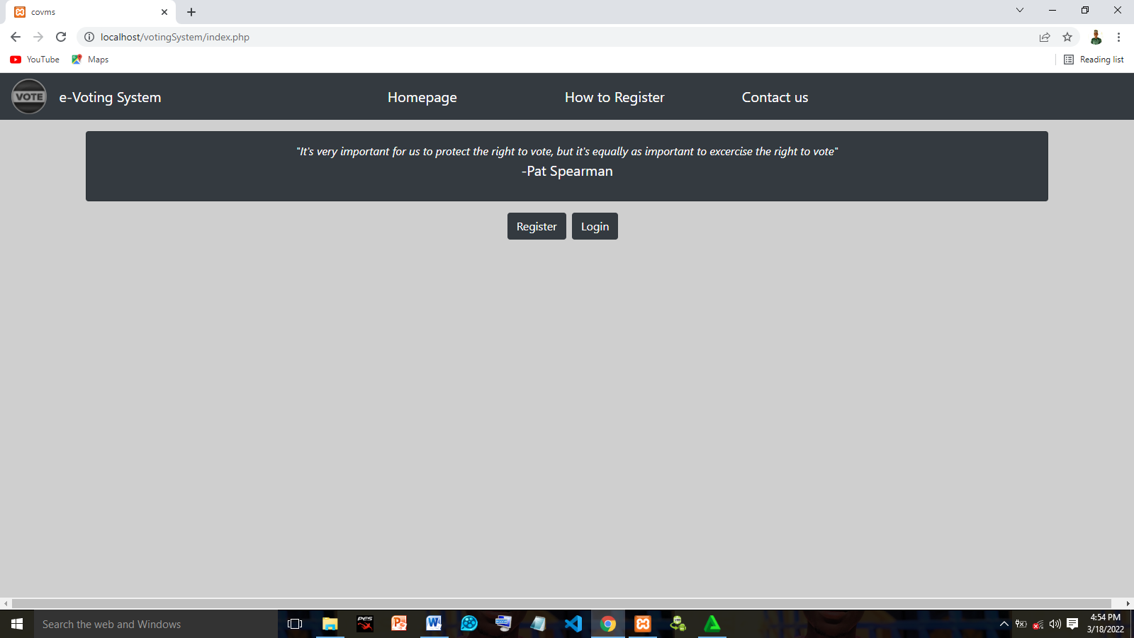

Figure 1: Register and Login Page

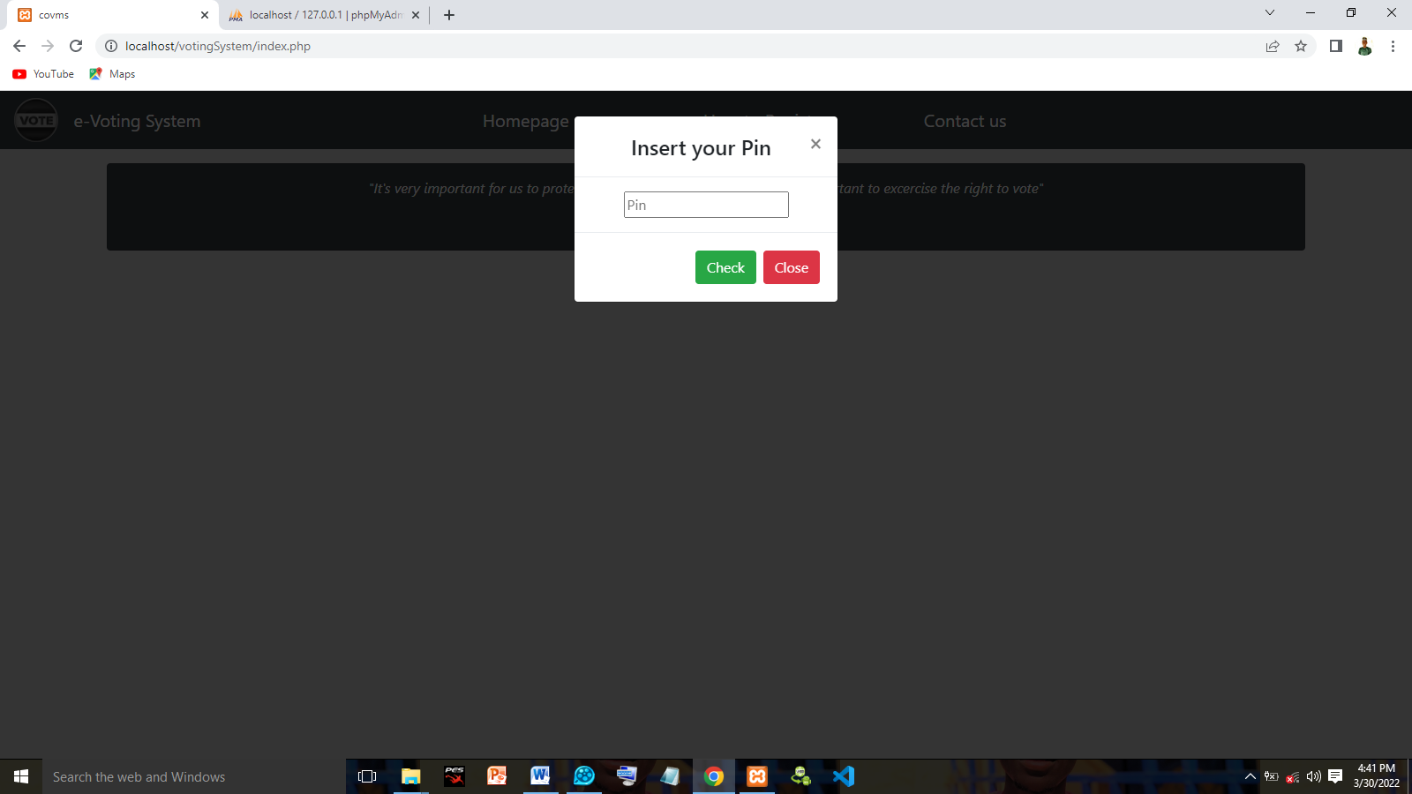

Figure 2: Pin Page provided from system administrator

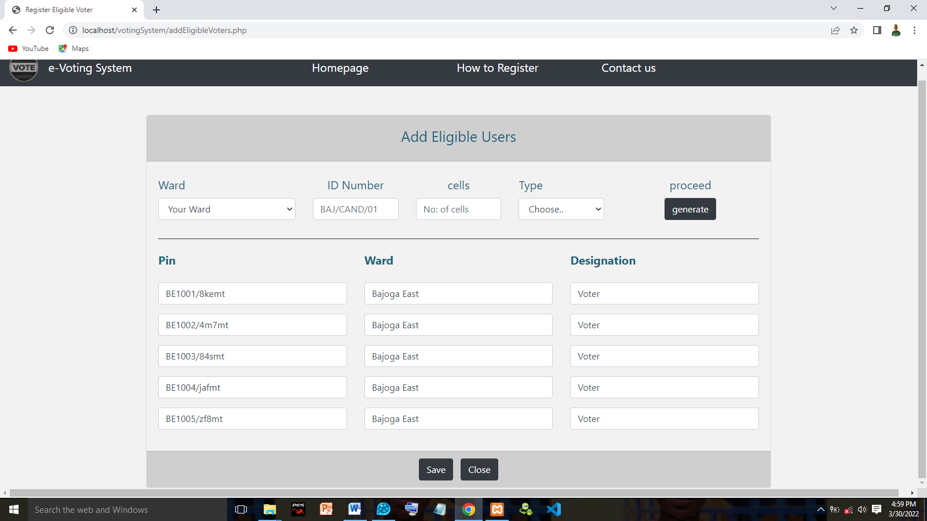

Figure 3: Page for generating user pin

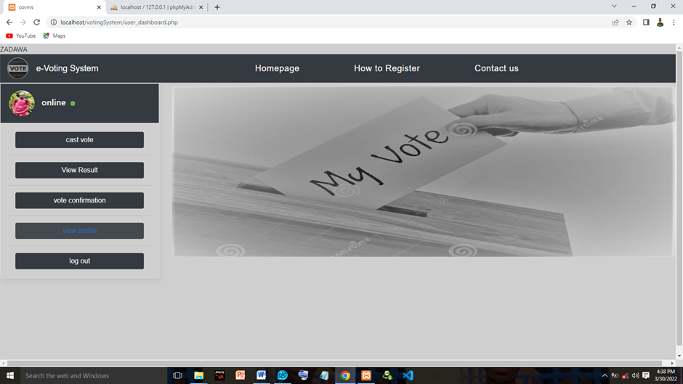

Figure 4: User Dashboard

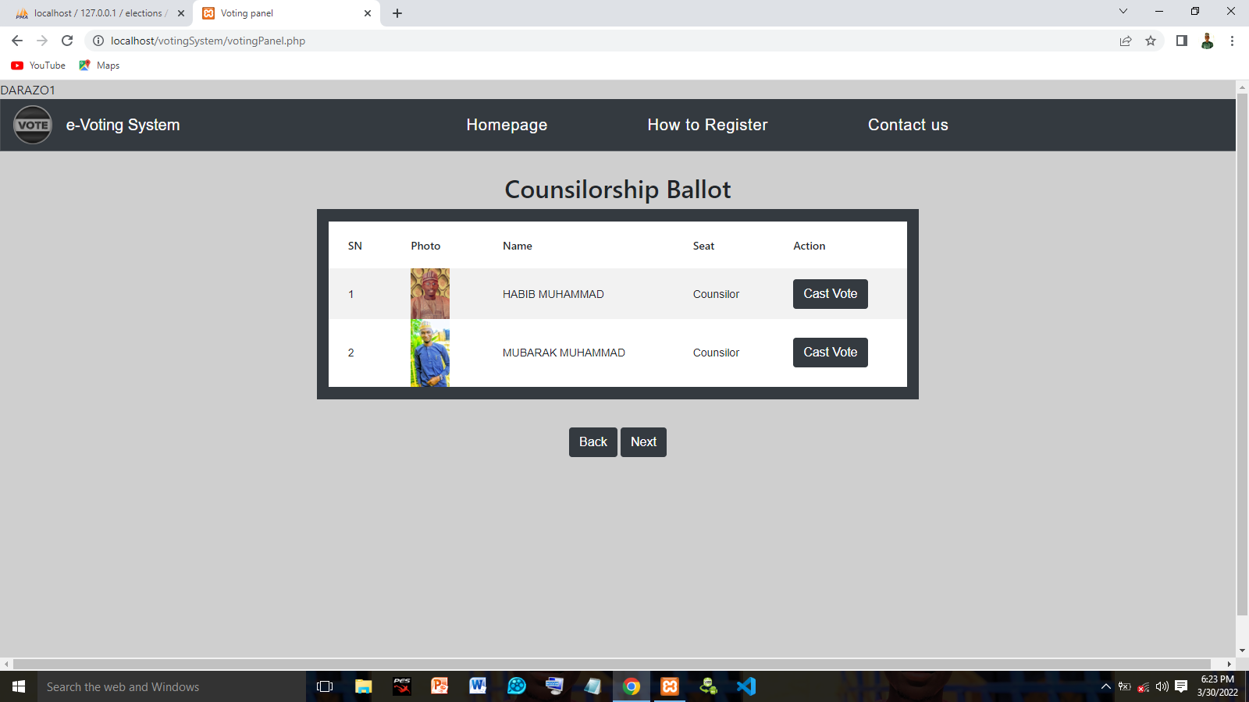

Figure 5: Page for Casting Vote

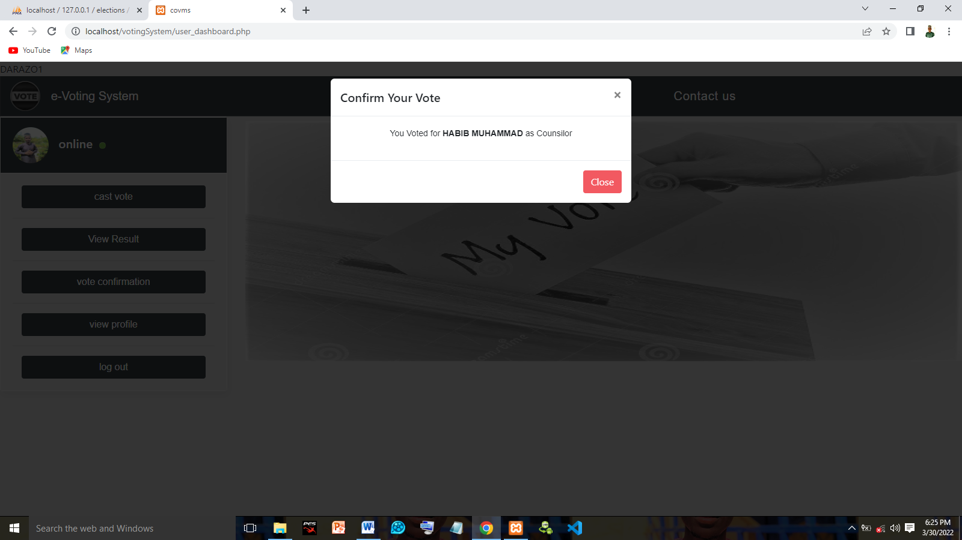

Figure 6: Page for Confirmation vote

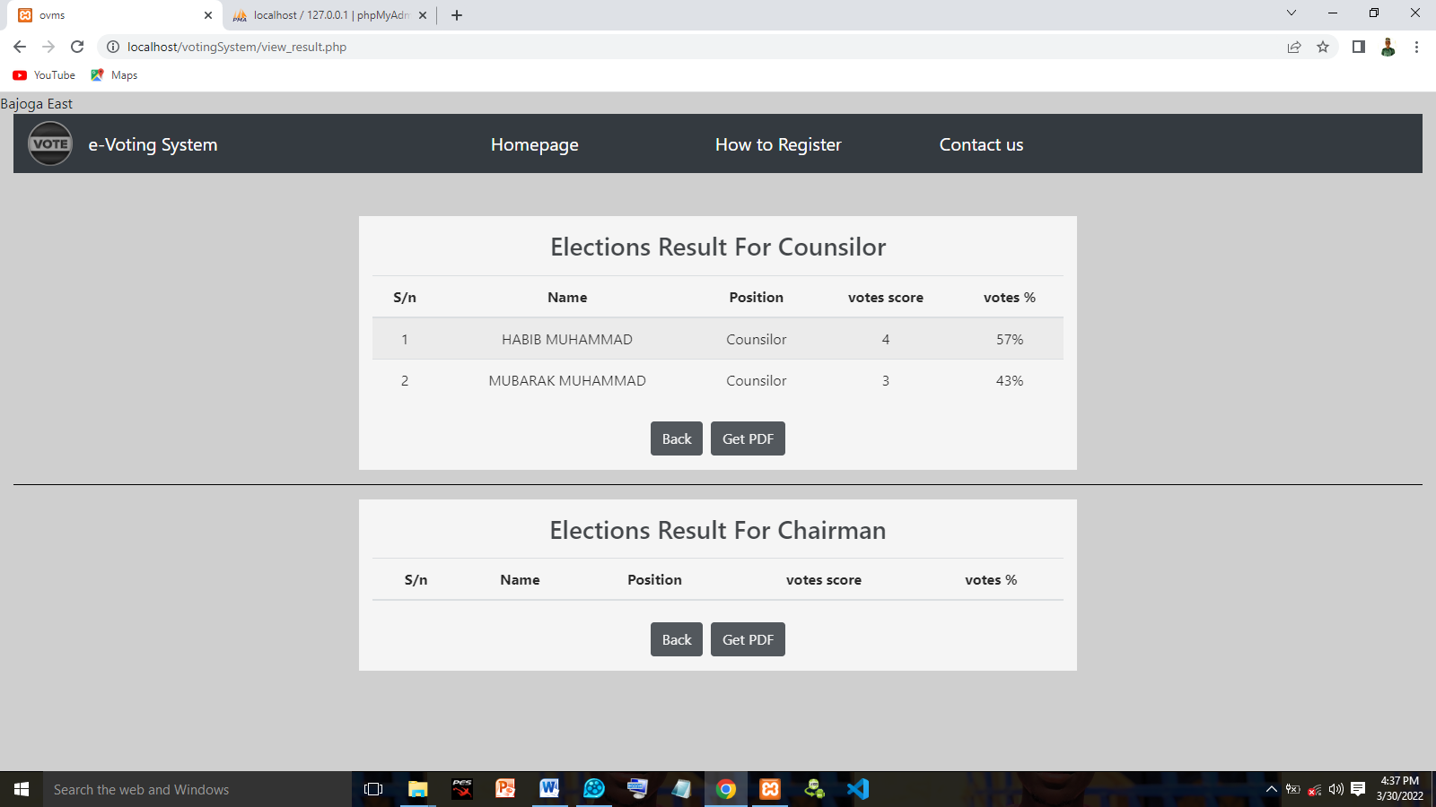

Figure 7: Page for showing the voting result

APPENDIX A

<?php
session_start();
include_once 'queries.php';
$obj = new dbquery();
// $insert_info ="";
extract($_GET);
extract($_SESSION);
if (isset($logout)) {
unset($_SESSION['username']);
}
if (isset($_POST['continue'])){
$userPin = $_POST['pin'];
if ($obj->ValidatePin($userPin)) {
if ($obj->checkRegistrationStatus($userPin)) {
echo "<script> alert('Note: Already Regidtered!!!')</script>";
header('Refresh:.0001; url=index.php');
} else {
$_SESSION['pin'] = $userPin;
echo "<script> alert('Note: proceed Register !!!')</script>";
header('Refresh:.0001; url=userRegistration.php');
}
} else {
echo "<script> alert('Note: Invalid Pin!!!')</script>";
header('Refresh:.0001; url = index.php');
}
exit;
$_SESSION['confirmed_pin'] = $_POST['pin'];

if(!empty($reg_no) || !empty($pin)){
if($obj->checkVoterDuplicateReg($reg_no)){
$insert_info = '<div class="btn btn-danger">Alread registered</div>';
}
else{
if($obj->checkifIDAndPinExists($reg_no,$pin)){

header('location:userRegistration.php');
}
else{
$insert_info = '<div class="btn btn-danger">You are not member</div>';
}
}
}
else{
$insert_info = '<div class="btn btn-danger">the fields cannot be null</div>';
}
}
?>
<!DOCTYPE html>
<html lang="en">
<head>
<meta charset="UTF-8">
<meta name="viewport" content="width=device-width, initial-scale=1.0">
<meta http-equiv="X-UA-Compatible" content="ie=edge">
<title>covms</title>
<!-- CSS Files -->
<link rel="stylesheet" href="bootstrap4/css/bootstrap.min.css">
<link rel="stylesheet" href="bootstrap.min.css">
<script src="bootstrap4/js/jquery.min.js"></script>
<script src="bootstrap4/js/bootstrap.min.js"></script>
<link rel="stylesheet" href="styles.css">
<style>
#body {
background-image: url(./images/homepage.gif);
background-position: center;
background-repeat: no-repeat, repeat;
padding: 15px;
height: 300px;
margin-top: -35px;

}
strong{
font-size: 18px;
}
</style>
</head>
<body style="background-color:rgb(207,207,207)">

<div class="wrapper">
<?php
include "includes_files/header.php";
?>
<div class="row justify-content-center">
<div class="card col-10 card bg-dark text-white mt-3">
<div class="card-body text-center">
<!-- <?= $insert_info; ?> -->
<div class="col-12" align="center" style="margin-top:-5px">
<em>"It's very important for us to protect the right to vote, but it's equally as important to excercise the right to vote"</em>
<div class="row justify-content-end">
<br><label class="text-white" style="margin-top:-5px">-Pat Spearman</label>
</div>
</div>

</div>
</div>
<div class = "col-6 mt-3" align="center">
<button class="btn btn-dark btn-md mx-1" name="login" data-toggle="modal" data-target="#register">Register</button>
<a href="login_page.php" class="btn btn-dark btn-md" name="Register" style="margin-right: 1rem;">Login</a>
</div>
</div>

</div>

<!-- The Modal -->
<div class="modal fade" id="register">
<div class="modal-dialog modal-sm">
<div class="modal-content">

<!-- Modal Header -->
<div class="modal-header">
<h4 class="modal-title ml-5">Insert your Pin</h4>
<button type="button" class="close" data-dismiss="modal">&times;</button>
</div>
<form action="" method="post">
<!-- Modal body -->
<div class="modal-body" align="center">
<input type="text" placeholder="Pin" name="pin" required>
</div>
<!-- Modal footer -->
<div class="modal-footer">
<button class="btn btn-success" name="continue">Check</button>
<button type="button" class="btn btn-danger" data-dismiss="modal">Close</button>
</div>
</form>
</div>
</div>
</div>
</body>
</html>

